Idaho Department of Lands
Director's Office
300 N. 6th Street, Suite 103
P.O. Box 83720
Boise, ID 83720-0050
Phone (208) 334-0200
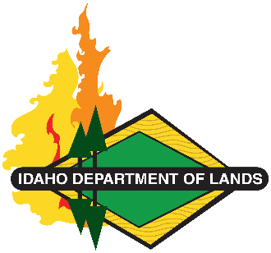
Dustin T. Miller, Director
Working Lands, Trusted Stewards
Equal Opportunity Employer
State Board of Land Commissioners
Brad Little, Governor
Phil McGrane, Secretary of State
Raúl R. Labrador, Attorney General
Brandon D Woolf, State Controller
Debbie Critchfield, Sup't Public Instruction

April 23, 2026
Re: Cancellation – IDL WITB 26-402 – Statewide Bridge Cancellation
This is notification of the Idaho Department of Lands cancellation of WITB 26-402 for the Statewide Bridge Inspection Project.

This solicitation is being issued as a Request for Statement of Qualifications (RFSoQ).

Thank you for your interest in supporting the Mission of the Idaho Department of Lands.

Respectfully,
Sherry Leason
Contracts Officer
IDAHO DEPARTMENT OF LANDS
3284 West Industrial Loop
Coeur d’Alene, ID 83815
sleason@idl.idaho.gov
Phone: 208-666-8659

