Idaho Department of Lands
Director's Office
300 N. 6th Street, Suite 103
P.O. Box 83720
Boise, ID 83720-0050
Phone (208) 334-0200
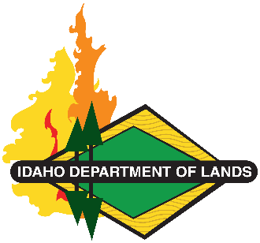
Dustin T. Miller, Director
Working Lands, Trusted Stewards
Equal Opportunity Employer

State Board of Land Commissioners
Brad Little, Governor
Phil McGrane, Secretary of State
Raúl R. Labrador, Attorney General
Brandon D Woolf, State Controller
Debbie Critchfield, Sup't Public Instruction

Qualifications Acknowledgement

Qualified Contractor’s Principal Investigator and field supervisor shall meet the Secretary of the Interior’s professional qualification (Appendix A of 36 CFR Part 61) standards for Archaeology. Other field crew members will have, at least, a bachelor’s degree in Anthropology or History. Please Acknowledge you have reviewed the Qualification per Appendix A of 36 CFR Part 61 standards for Archaeology and that the representatives your company will provide have the minimum required qualifications by signing below.

Acknowledged by (Print Name):

Title:

Signature:

Date:

