Idaho Department of Lands
Director's Office
300 N. 6th Street, Suite 103
P.O. Box 83720
Boise, ID 83720-0050
Phone (208) 334-0200
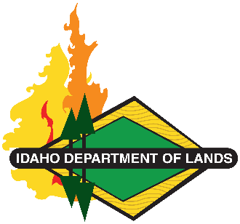
Dustin T. Miller, Director
Working Lands, Trusted Stewards
State Board of Land Commissioners
Brad Little, Governor
Phil McGrane, Secretary of State
Raúl R. Labrador, Attorney General
Brandon D Woolf, State Controller
Debbie Critchfield, Sup't Public Instruction

REGARDING: IDL RFQ 26-235-021001 – JOHNSON-GOODRICH SURVEYS - ADDENDUM 1

This ADDENDUM 1 is sent with a correction for the original solicitation released on June 30, 2026.

- The acres identified for this project are corrected. The total acres identified for survey are changed from 1,057 to 1,075.

All other terms and conditions remain the same.

This correction does not change the due date of the RFQ. This solicitation closes: July 15, 2026 @ 12:00 p.m., PT.

Sherry Leason
Contracts Officer
Idaho Department of Lands
3284 W Industrial Loop
Coeur d'Alene, ID 83815
sleason@idl.idaho.gov
208.666.8659 Direct

