Idaho Department of Lands
Director's Office
300 N. 6th Street, Suite 103
P.O. Box 83720
Boise, ID 83720-0050
Phone (208) 334-0200
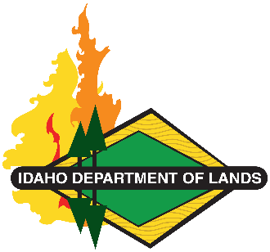
Dustin T. Miller, Director
Working Lands, Trusted Stewards
Equal Opportunity Employer

State Board of Land Commissioners
Brad Little, Governor
Phil McGrane, Secretary of State
Raúl R. Labrador, Attorney General
Brandon D Woolf, State Controller
Debbie Critchfield, Sup't Public Instruction

BLOSSOM SURVEY
Acknowledgement of Idaho Code Title 18, Chapter 87
Contractor Name TBD
Acknowledge the following by singing below:
Disclosure of Abortion Related Matters. The State is subject to the No Public Funds for Abortion Act, Idaho Code title 18, chapter 87 (the “Act”) and State employees who intentionally violate the provisions of the Act are subject to criminal prosecution. This provision is included in this letter to aid in compliance with the Act. The state of Idaho (State) requests that Contractor disclose, unless Contractor is within one of the exemptions provided in the Act, if it or an affiliate is or becomes, during the term of the Contract, an abortion provider and if it will use State facilities or public funds to provide, perform, participate in, promote or induce, assist, counsel in favor, refer or train a person for an abortion related activity. Please refer to the Act for definitions of the terms used in this section.

Acknowledged by (Print Name):

Title:

Signature:

Date:

