Idaho One Plan Template
For Multiple-Use Forest Management on Private Lands
November 2016

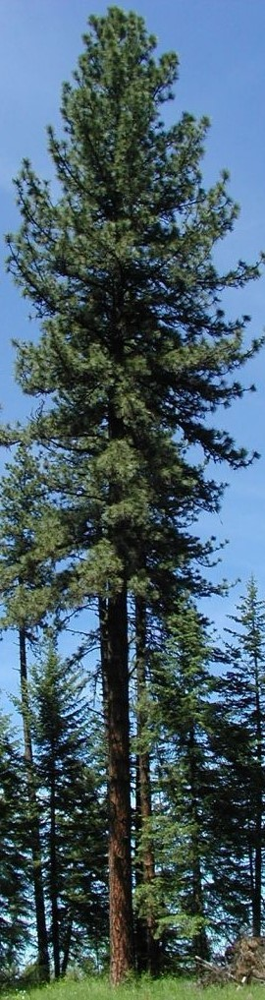

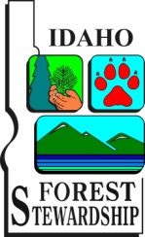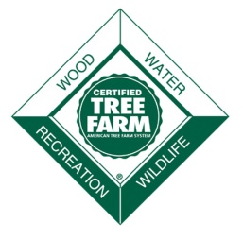
Overview
This template provides a simple way to write forest management plans that meet requirements of Idaho’s Forest Stewardship Program, the Idaho Tree Farm System and the Natural Resource Conservation Service. Plan writers should use the template as a framework to ensure that all planning elements are addressed consistent with all program guidelines.
Full instructions on completing this template and the required elements are more fully described in the companion “Idaho One Plan Guide”. The plan preparer can provide additional resource information as appropriate to meet the landowner needs. Appendices with this template provide additional information that can be useful to the landowner.
Maps:
- An electronic copy of the plan, including maps is required for participation in each program.
- Include a directional arrow, legend, and delineate property boundaries, stands (management units), special sites, etc.
- To minimize file size, it is recommended that maps generated in ArcGIS be exported and saved as a JPEG, with a resolution of 96 dpi.
Signatures:
A landowner signature page is provided with this template. A landowner must sign and initials this page to indicate the programs for which this plan will be applied.

Multiple-Use Forest Management – One Plan
For Private Lands in Idaho
For

Date of Original Plan:
Revision Date (If applicable)
Resident of the Land: Absentee Owner:
Landowner Contact Information
Full Name:
Group Name:
Address:
Phone:
Email:
Plan Author Contact Information
Plan Author Name:
Company:
Phone:
Email:
Author Signature:

PROPERTY DESCRIPTION

Total Plan Acres: Total Forested Acres:

Legal Description:
Subdivision | Section | Township | Range

Latitude (decimal degree): Longitude (decimal degree):
Watershed:
Fire Protection District: FPD Phone Number:
Adjacent land use: (e.g. on the north side of the property is a pasture, the other three sides are timbered. Adjacent ownership are 10-40 acres. Ownership is a mix of state and private.)

Accessibility: (describe how one accesses the property and what type of traffic is suitable for roads on the property)

Topography, elevation, aspect:
Number of unique stand of trees or management units:

Introduction
Explain the plans purpose and how it relates to the landowners values. Give a brief description of general conditions, past history and management of the property.

Landowner Goals and Objectives
Describe what the landowner wants to achieve on their property.
Goals: (broad statements of desired outcomes for the property)
1.
2.
3.
4.
5.
6.
Objectives: (Planned actions, specific and measurable to achieve goals)
1.
2.
3.
4.
5.
6.

Property Map
Insert map on this page

Soil Survey Map
Insert map on this page
Topographic Map
Insert map on this page
Natural Resource Element for Forest Management Plans
NOTE: For all plan elements describe the current condition and provide recommendations that consider the landowner’s goals and objectives.
Special Sites and Social Considerations
- Archeological, Cultural and Historic Sites (Intent is to protect known landscapes, structures, archeological artifacts and vegetation that represent a cultural or society historic value)

- Aesthetics (Describe the desired condition that would maintain or enhance aesthetic qualities. Consider how management may affect desired outcome.)

- Recreation (Describe the type of forest-oriented recreation activities valued by the landowner e.g. birding, hiking trails, hunting, fishing, gathering and camping.)

- Forest of Recognized Importance (These forests are recognized at the landscape level, rather than the stand level and are recognized for the combination of unique values.)

- Conservation-based Estate/Legacy Planning or Land Transfer (Consider the future use of the ownership to help ensure working forests.)

Soil, Water and Air Protection
- Soils (Refer to the soils map. Diverse conditions may necessitate different descriptions on the property. Include slopes, aspects, and Forest Practice Act (FPA) limitations.)

- Roads and Access (Describe roads, trails, type of access and any restrictions, improvements and maintenance.)

- Water and Wetlands (Describe water features on the property, both man-made and natural. Include streams, riparian areas, swamps, marshes, bogs and FPA classifications.)

- Carbon Sequestration and Climate Resilience (To maintain healthy resilient forests, consider climate change information and develop management recommendations that will help adapt, or prepare the forest for expected local changes.)

Fish, Wildlife and Biodiversity
- Fish and Wildlife (Indicate the presence of fish and wildlife. Consider current and future desired habit conditions for fish and wildlife.)

- Threatened and Endangered Species (Address rare, threatened and endangered species.)

- Biodiversity (Include the diversity of species and ecosystems and genetic diversity and the processes that support them.)

Forest Health and Fire
- Forest Health (Include observed signs and symptoms of insects and disease, overstocked stands and other factors that create unhealthy forest conditions.)

- Invasive Species (Address the presences of invasive species (noxious weeds) on the property and potential threats from neighboring property.)

- Fire Resilient Forests (Identify fire threats to the forest, species adaptation or dependence on fire, hazard fuel reduction and prescribe burn opportunities.)

- Home Firewise and Fire Adapted Communities (Include mitigating risk to the home and surrounding landscapes and working with neighbors to reduce fire threats)

Range and Agroforestry
- Range (Indicate the presence of range in terms of extent and condition, which may include native and introduced grasses, forbs, brush, livestock and other animals.)

- Agroforestry/Silvopasture (Combines agriculture and forestry to create an integrated and sustainable land use system)

Forest Management
Provide an overview of timber resources and describe specific unit or stand characteristics e.g. average age and diameter of trees, dominant species, current and future desired conditions, etc. Delineate management units/stands on appropriate maps and identify them by numbers or letters.
Recommend sound silvicultural practices designed to help establish new forest stands, manage the existing trees, or implement a harvest activity to reach desired future stand conditions based on landowner management objectives. Indicate when a Notification for Forest Practices or special permits or licenses are needed.
Forest management considerations
- Harvesting
- Slash management
- Post-harvest practices
- Stream Protection Zones (SPZ)
- Reforestation or afforestation
- Timber stand improvement and other silvicultural treatments
- Monitoring
- Other information as needed (e.g. delineate stands for weed control, riparian restoration, hazard fuel treatment, special sites, etc.)

Appendix A
Management Plan Implementation Schedule
Unit # | Treatment Date  (Season & Year) | Short Description of Treatment/Practice | NRCS  Practice Code | Acres or Feet to Treat | Applied Practice
 |  |  |  |  | Cost | Date
 |  |  |  | subtotal
 |  |  |  | subtotal
 |  |  |  | subtotal
 |  |  |  | subtotal
 |  |  |  | subtotal

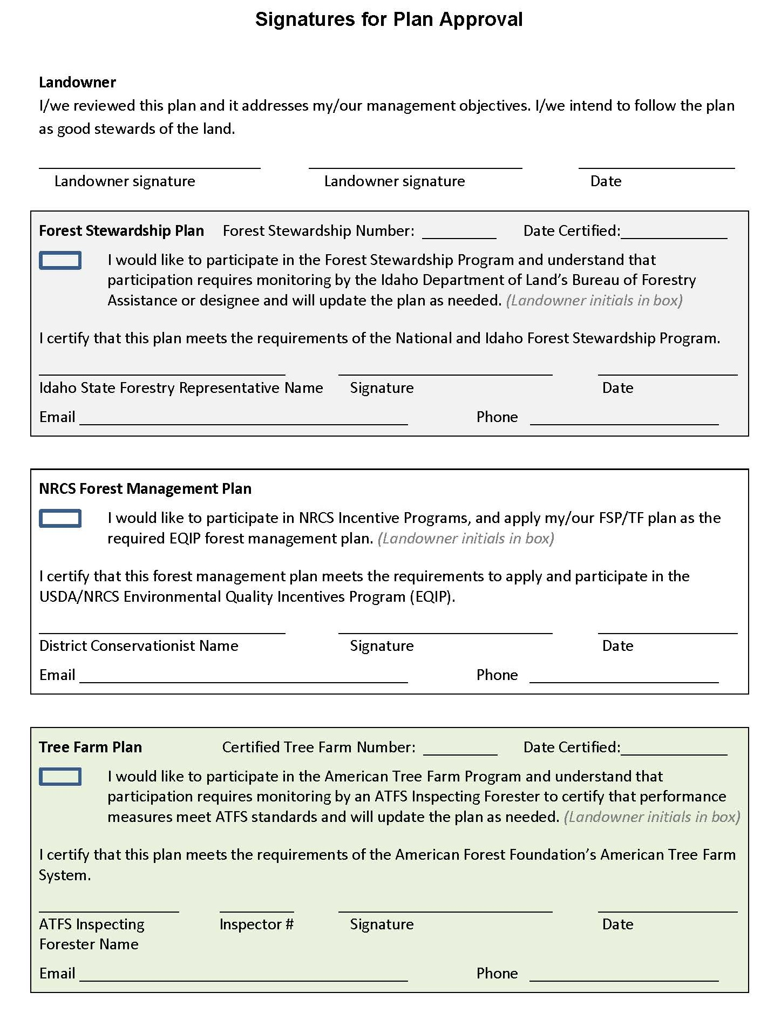

Appendix B:

Glossary
Acceptable Growing Stock: Saleable trees that are of good form, species and quality and would be satisfactory as crop trees.

Adaptive management: A dynamic approach to forest management in which the effects of treatments and decisions are continually monitored and used to modify management on a continuing basis to ensure that objectives are being met. (Helms et al, The Dictionary of Forestry, Society of American Foresters, 1998)

Adverse regulatory actions: Written warning, citations or fines issued by law enforcement or regulatory bodies.

Aerial Photo: Photo taken from an elevated position like on an aircraft.

Afforestation: the establishment of a forest or a stand in an area where the preceding vegetation or land was not forest. (Helms et al, The Dictionary of Forestry, Society of American Foresters, 1998)

Age Class: A distinct aggregation of tree that originated at the same time, from a single natural event or regeneration activity or a grouping of trees (e.g. ten year age class) as used in inventory or management. (Helms et al, The Dictionary of Forestry, Society of American Foresters, 1998)

Aspect: The direction that a slope faces (north, south, etc.)

Basal Area: The cross-sectional area of a tree, in square feet, at 4.5 feet from the ground (at breast height). When the basal area of all the trees in a stand are added together, the result is expressed as square feet of basal area per acre, which is a measure of a stand’s density.

Biomass: A renewable energy source of biological materials derived from living, or recently living organisms, such as wood, waste, and crop residues.

Biodiversity: The variety and abundance of life forms, processes, functions and structures of plants, animals and other living organisms, including the relative complexity of species, communities, gene pools and ecosystems at spatial scales that range from local through regional to global. (Helms et al, The Dictionary of Forestry, Society of American Foresters, 1998)

Board Feet: A unit for measuring wood volumes. It is commonly used to express the amount of wood in a tree, sawlog, or individual piece of lumber. A piece of wood 1 foot long, 1 foot wide, and 1 inch thick (144 cubic inches).

Broadcast: to spread or apply seed, fertilizer, or pesticides more or less evenly over an entire area. (Helms et al, The Dictionary of Forestry, Society of American Foresters, 1998)

Canopy: The more or less continuous cover of branches and foliage formed collectively by the tops, or crowns of adjacent trees.

Carbon sequestration: The incorporation of carbon dioxide into permanent plant tissue. (Helms et al, The Dictionary of Forestry, Society of American Foresters, 1998)

Chip: A small piece of wood used to make pulp or wood composite or fuel. (Helms et al, The Dictionary of Forestry, Society of American Foresters, 1998)

Clearcut: 1. A stand in which essentially all trees have been removed in one operation – note depending on management objectives, a clearcut may or may not have reserve trees left to attain goals other than regeneration. 2. A regeneration or harvest method that removes essentially all trees in a stand. (Helms et al, The Dictionary of Forestry, Society of American Foresters, 1998)

Contour Map: A map where each line represents a change in elevation.

Crop Tree: A tree identified to be grown to maturity for the final harvest cut, usually on the basis of its location with respect to other trees and its timber quality.

Cull: A tree, log, lumber or seedling that is rejected because it does not meet certain specifications for usability or grade. (Helms et al, The Dictionary of Forestry, Society of American Foresters, 1998)

Culvert: A device used to channel water. It may be used to allow water to pass underneath a road, railway, or embankment for example. Culverts can be made of many different materials; steel, polyvinyl chloride (PVC) and concrete are the most common. Formerly, construction of stone culverts was common.

Den Tree: A living tree with a cavity large enough to shelter wildlife.

Desired species: Those species of flora and fauna designated in the landowner’s management plan and not known to cause negative impacts on the local environment.

Diameter Breast Height (DBH): The diameter of a tree at 4.5 feet above the ground.

Endangered Species: Any species of plant or animal defined through the Endangered Species Act of 1976 as being in danger of extinction throughout all or a significant portion of its range, and published in the Federal Register. (Helms et al, The Dictionary of Forestry, Society of American Foresters, 1998)

Even-Aged Management: Forest management with periodic harvest of all trees on part of the forest at one time or over a short period to produce stands containing trees all the same or nearly the same age or size.

Forest owner: Landowner or designated representative such as, but not limited to, professional resource manager, family member, trustee, etc.

Forest product: [Forest Produce] Any raw material yielded by a forest. Generally defined in Forest Acts or Ordinances, and subdivided conventionally into major forest products, i.e. timber and fuelwood, and minor forest products, i.e. all other products including leaves, fruit, grass, fungi, resins, gums, animal parts, water, soil, gravel, stone and other minerals on forest land. (F. C. Ford –Robertson, Terminology of Forest Science Technology, Practice, and Products, Society of American Foresters, 1971)

Forest Stand Improvement: See timber stand improvement.

Forest type: A category of forest usually defined by it trees, particularly its dominant tree species as based on percentage cover of trees, e.g. spruce fir, pine, Douglas fir.

Forest vitality: The health and sustainability of a forest.

Fuel management: The act or practice of controlling flammability and reducing resistance to control of wildland fuels through mechanical, chemical, biological, or manual means, or by fire in support of land management objectives. (Helms et al, The Dictionary of Forestry, Society of American Foresters, 1998)

Group Select: Trees are removed and new age classes are established in small groups – note – 1. the width of groups is commonly approximately twice the height of the mature trees with smaller openings providing microenvironments suitable for tolerant regeneration and larger openings providing conditions suitable for more intolerant regeneration – note 2. the management unit or stand in which regeneration, growth, and yield are regulated consists of an aggregation of groups. (Helms et al, The Dictionary of Forestry, Society of American Foresters, 1998)

Girdling: Completely encircling the trunk of a tree with a cut that severs the bark and cambium of the tree. Herbicide is sometimes injected into the cut to ensure death of the tree.

GPS (Global Positioning System) Coordinates: A commonly hand held, satellite based navigational device that records x, y, z coordinators and other data allowing users to determine their location on the surface of the earth. (Helms et al, The Dictionary of Forestry, Society of American Foresters, 1998)

Hack-n-squirt: A tree treatment method where an axe or hatchet is used to make "hacks" (injections) into the tree's cambium layer. A plastic "squirt" bottle is used to spray a specific amount of herbicide into the cuts placed around the tree.

Harvesting: The felling skidding, on-site processing, and loading of trees or logs onto trucks. (Helms et al, The Dictionary of Forestry, Society of American Foresters, 1998)

High conservation value forests (HCVF): Forests of outstanding and critical importance due to their environmental, social, biodiversity or landscape values. Due to the small scale and low-intensity of family forest operations, informal assessment of HCVF occurrence through consultation with experts or review of available and accessible information is appropriate.

High-grading: Cutting only the high-value trees from a forest property, leaving a stand of poor quality with decreased future timber productivity.

Incentive Programs: State and federal agencies will offer landowners the opportunity to apply for incentive programs that will provide support and financial assistance to implement forestry and agroforestry related practices through conservation programs. Assistance can also be provided for multi-year and permanent easements to conserve forest land to meet program goals.

Integrated Pest Management: The maintenance of destructive agents, including insects, at tolerable levels by planned use of a variety of preventative, suppressive, or regulatory tactics and strategies that are ecologically and economically efficient and socially acceptable (Helms et al, The Dictionary of Forestry, Society of American Foresters, 1998). A pest control strategy that uses a variety of complementary strategies including: mechanical devices, physical devices, genetic, biological or cultural management and chemical management. (US EPA)

Intermediate Cut: Removing immature trees from the forest sometime between establishment and stand harvest to improve the quality of the remaining forest stand. Contrast this technique with a harvest cut.

Invasive species: Non-native species whose introduction does or is likely to cause economic or environmental harm or harm to human health. (Executive Order 13112 (Feb. 3, 1999))

Invasive Species: Is a species that is 1) non-native (or alien) to the ecosystem under consideration and 2) whose introduction causes or is likely to cause economic or environmental harm or harm to human health. Invasive species can be plants, animals, and other organisms (e.g., insects, microbes, etc.). Human actions are the primary means of invasive species introductions. (Invasive Species Definition Clarification and Guidance White Paper Submitted by the Definitions Subcommittee of the Invasive Species Advisory Committee (ISAC), Approved by ISAC Apr 27, 2006.)

Landings: A cleared area in the forest to which logs are yarded or skidded for loading onto trucks for transport. (Helms et al, The Dictionary of Forestry, Society of American Foresters, 1998)

Landowner: Entity that holds title to the property for which the management plan is being written.

Large woody debris: Any piece(s) of dead woody material, e.g. dead boles, limbs and large root masses, on the ground in the forest stands or in streams. (Helms et al, The Dictionary of Forestry, Society of American Foresters, 1998)

Log Rules: A table showing estimated amount of lumber that can be sawed from logs of given lengths and diameters. Two log rules are commonly used:
Doyle Rule is a simple formula rule used in the eastern United States. It underestimates the amount of lumber in small logs and overestimates large logs. International 1/4-inch Rule is a formula rule allowing 1/2 –inch taper for each 4 feet of length and 1/16-inch shrinkage for each one-inch board. This measure approximates the actual sawmill lumber tally.

Management plan: Documents that guide actions and that change in response to feedback and changed conditions, goals, objectives and policies. Management plans may incorporate several documents including, but not limited to, harvest plans, activity implementation schedules, permits, research, etc. For the purposes of the American Tree Farm System® eligible management plans, plan amendments may include letters, notes, and other forms of informal updates in addition to formal plan revisions.

Mast: Nuts of trees, such as oak, walnut, and hickory, that serves as food for many species of wildlife.

Mature Tree: A tree that has reached the desired size or age for its intended use.

MBF: Abbreviation for 1,000 board feet.

Noxious plant (weed): A plant specified by law as being especially undesirable, troublesome and difficult to control. (Helms et al, The Dictionary of Forestry, Society of American Foresters, 1998)

Nutrient cycle: The exchange or transformation of elements among the living and nonliving components of the ecosystem. (Helms et al, The Dictionary of Forestry, Society of American Foresters, 1998)

Overstocked: A forest stand condition where too many trees are present for optimum tree growth.

Overstory: That portion of the trees in a stand forming the upper crown cover.

Overstory removal: The cutting of trees constituting an upper canopy layer to release trees or other vegetation in an understory. (Helms et al, The Dictionary of Forestry, Society of American Foresters, 1998)

Pesticide: Pesticides include chemicals commonly known as herbicides and insecticides.

Pole Timber: Trees from 6 inches to 12 inches in diameter at breast height.

Prescribed Burn/Fire: To deliberately burn natural fuels under specific weather conditions, which allows the fire to be confined to a predetermined area and produces the fire intensity to meet predetermined objectives. A fire ignited by management to meet specific objectives. (Helms et al, The Dictionary of Forestry, Society of American Foresters, 1998)

Pruning: Removing live or dead branches from standing trees to improve wood quality.
Pulpwood: Wood cut primarily for manufacture of paper, fiberboard, or other wood fiber products.

Qualified contractor: Forest contractors who have completed certification, licensing, recommended training and education programs offered in their respective states.

Qualified natural resource professional: A person who by training and experience can make forest management recommendations. Examples include foresters, soil scientists, hydrologists, forest engineers, forest ecologists, fishery and wildlife biologists or technically trained specialists in such fields.

Qualified Tree Farm inspector: A natural resource professional who has completed ATFS required training for certifying forested properties and is eligible to inspect properties on behalf of ATFS. ATFS requires all trained inspectors meet approved eligibility requirements.

Rangeland: Land on which the historic climax plant community is predominantly grasses, grasslike plants, forbs, or shrubs. Includes lands revegetated naturally or artificially when routine management of that vegetation is accomplished mainly through manipulation of grazing. Rangelands include natural grasslands, savannas, shrublands, most deserts, tundra, alpine communities, coastal marshes, and wet meadows.

Rare species: A plant or animal or community that is vulnerable to extinction or elimination.

Reforestation: The reestablishment of forest cover either naturally (by natural seeding, coppice, or root suckers) or artificially (by direct seeding or planting) – note reforestation usually maintains the same forest type and is done promptly after the previous stand or forest was removed. (Helms et al, The Dictionary of Forestry, Society of American Foresters, 1998)

Regeneration: The number of seedlings or saplings existing in a stand. The process by which a forest is renewed by direct seeding, planting, or naturally by self-sown seeds and sprouts.

Regeneration Cut: Any removal of trees intended to assist regeneration already present or to make regeneration possible.

Release: To free trees from competition by cutting, removing, or killing nearby vegetation.

Riparian: Related to, living or located in conjunction with a wetland, on the bank of a river or stream but also at the edge of a lake or tidewater – note the riparian community significantly influences and is significantly influenced by, the neighboring body of water. (Helms et al, The
Dictionary of Forestry, Society of American Foresters, 1998)

Riparian Zone: The area adjacent to or on the bank of rivers and streams.

Sapling: Trees from 2 inches to 6 inches in diameter at breast height.

Sawtimber: Trees at least 12 inches in diameter at breast height from which a sawed product can be produced.

Scale: The extent of forest operations on the landscape/certified property.

Seedling: A young plant.

Seed-tree Harvest: A harvest and regeneration method where nearly all trees are removed at one time except for scattered trees to provide seed for a new forest.

Selection Harvest: Harvesting trees to regenerate and maintain a multi-aged structure by removing some trees in all size classes either singly or in small groups.

Shelterwood Harvest: A harvesting and regeneration method that entails a series of partial cuttings over a period of years in the mature stand. Early cuttings improve the vigor and seed production of the remaining trees. The trees that are retained produce seed and also shelter the young seedlings. Subsequent cuttings harvest shelterwood trees and allow the regeneration to develop as an even-aged stand.

Single Tree Selection: Individual trees of all size classes are removed more or less uniformly throughout the stand, to promote growth of remaining trees and to provide space for regeneration. (Helms et al, The Dictionary of Forestry, Society of American Foresters, 1998)

Site Index: An expression of forest site quality based on the height of a free-growing dominant or co-dominant tree at age 50 (or age 100 in the western United States).

Skid: 1. To haul a log from the stump to a collection point (landing) by a skidder. 2. A load pulled by a skidder. (Helms et al, The Dictionary of Forestry, Society of American Foresters, 1998)

Skid Trail: A road or trail over which equipment or horses drag logs from the stump to a landing.

Skidding: Pulling logs from where they are cut to a landing or mill.

Skyline: Harvesting a cableway stretched tautly between two points, such as yarding tower and stump anchor, and used as a track for a block or skyline carriage. (Helms et al, The Dictionary of Forestry, Society of American Foresters, 1998)

Slash: The residue, e.g., treetops and branches, left on the ground after logging or accumulating as a result of storm, fire, girdling, or delimbing. (Helms et al, The Dictionary of Forestry, Society of American Foresters, 1998)

Snag: A standing, generally un-merchantable dead tree from which the leaves and most of the branches have fallen – note for wildlife habitat purposes, a snag is sometimes regarded as being at least 10 inches in diameter at breast height and at least 6 feet tall; a hard snag is composed primarily of sound wood, generally merchantable, and a soft snag is composed primarily of wood in advanced stages of decay and deterioration. (Helms et al, The Dictionary of Forestry, Society of American Foresters, 1998)

Soil Compaction: The process by which the soil grains are rearranged, resulting in a decrease in void space and increasing bulk density. Can occur from applied loads, vibration or pressure from harvesting or site preparation equipment. Compaction can cause decreased tree growth, increased water runoff and soil erosion. (Helms et al, The Dictionary of Forestry, Society of American Foresters, 1998)

Soil map: A map showing the distribution of soils or other soil map units in relation to prominent physical and cultural features of the earth’s surface. (Helms et al, The Dictionary of Forestry, Society of American Foresters, 1998)

Special sites: Those areas offering unique historical, archeological, cultural, geological, biological or ecological value. Special Sites include:
  - Historical, archaeological, cultural and ceremonial sites or features of importance to the forest owner;
  - Sites of importance to wildlife such as rookeries, refuges, fish spawning grounds, vernal ponds and shelters of hibernating animals;
  - Unique ecological communities like relic old-growth, springs, glades, savannas, fens and bogs; and
  - Geological features such as terminal moraines, cliffs and caves.
Stand: A group of trees with similar characteristics, such as species, age, or condition that can be distinguished from adjacent groups. A stand is usually treated as a single unit in a management plan.

Stand Density: A measure of the stocking of a stand of trees based on the number of trees per area and diameter at breast height of the tree of average basal area.

Stand Management Recommendations: The recommended management activities that should be done in that stand, based on the landowner’s goals and objectives.

Stand Structure: The horizontal and vertical distribution of plants in the forest, including the height, diameter, crown layers, and stems of trees, shrubs, understory plants, snags and down woody debris. (Helms et al, The Dictionary of Forestry, Society of American Foresters, 1998)

State forestry best management practice(s) (BMPs): Forestry BMPs are generally accepted forest management guidelines that have been developed by state forestry agencies with broad public stakeholder input.

Stocking: An indication of the number of trees in a stand in relation to the desirable number of trees for best growth and management.

Sustainability: The capacity of forests, ranging from stands to ecoregions, to maintain their health, productivity, diversity and overall integrity, in the long run, in the context of human activity. (Helms et al, The Dictionary of Forestry, Society of American Foresters, 1998)

Sustainable forest management: The practice of meeting the forest resource needs and values of the present without compromising the similar capability of future generations. (Helms et al, The Dictionary of Forestry, Society of American Foresters, 1998) Note – AFF’s Standards of Sustainability reflect criteria of sustainability based on the Montreal Process, 1993, and the Pan-European Operational- Level Guidelines (PEOLGs).

Thinning: A cultural treatment made to reduce stand density of trees primarily to improve growth, enhance forest health, or recover potential mortality. Types of thinning include: chemical, crown, free, low, mechanical, selection. (Helms et al, The Dictionary of Forestry, Society of American Foresters, 1998)

Threatened Species: A plant or animal species that is likely to become endangered throughout all or a significant portion of its range within the foreseeable future. A plant or animal identified and defined in the Federal Register in accordance with the Endangered Species Act of 1976. (Helms et al, The Dictionary of Forestry, Society of American Foresters, 1998)

Timber Stand Improvement (TSI): A thinning made in immature stands to improve the composition, structure, condition, health, and growth of the remaining trees.

Undesirable Growing Stock: Trees of low quality or less valuable species that should be removed in a thinning.

Understocked: Insufficiently stocked with trees.

Understory: All forest vegetation growing under an overstory. (Helms et al, The Dictionary of Forestry, Society of American Foresters, 1998)

Uneven-Aged Management or Stand: A stand of trees containing at least three age classes intermingled on the same area.

Visual quality measures: Modifications of forestry practices in consideration of public view, including timber sale layout, road and log landing locations, intersections with public roadways, distributing logging residue, tree retention, timing of operations and other factors relevant to the scale and location of the project.

Volume: The amount of wood in a tree, stand of trees, or log according to some unit of measurement, such as board foot, cubic foot, etc.

Watershed: The area of land where all of the water that is under it or drains off of it goes into the same place. For example the Mississippi River watershed includes all the land that drains into the Mississippi River. This watershed is the fourth largest in the world and includes water from 31 states.

Wetland: A transitional area between water and land that is inundated for periods long enough to produce wet soil and support plants adapted to that environment. (Helms et al, The Dictionary of Forestry, Society of American Foresters, 1998)

Wolf Tree: A very large, overmature tree that is or was open grown. These trees tend to have large full crowns and numerous branches.

Woody Debris: Any piece(s) of dead woody material (e.g. dead tree trunk, limbs, large root ball) on the ground in the forest or in streams. (Helms et al, The Dictionary of Forestry, Society of American Foresters, 1998)

Appendix C:

Tax and Business Management
Woodland owners have to deal with property taxes, income tax for timber harvests and other revenue generating activities, and estate taxes when properties are passed on to future generations. This section was developed to help consider tax implication as part of the planning process.

Consider addressing the following in your plan:

- Property tax: The forest management plan should document the current tax status of the property. Your state might have specific property tax programs that you may be eligible to participate in. Please be aware of the program rules and regulations.

- Income tax: Include a statement that timber harvest and other revenue generating activities generally produce a federal and state income tax liability. Tax credits may be available for some management activities.

- Federal and State Incentive Programs: There is tax implication for participating so be aware of those implications.

- Estate tax: Good estate planning can help to lessen tax liability when passing land to heirs and landowners should seek good planning and tax advice.

- Record keeping: Good record keeping can help landowners manage their assets, increase their revenues, and minimize their tax liability.

- Land Use: Document the land use classifications of the property from the county land use plan.

It is recommended that you work with a professional tax advisor who can assist you in developing this section.

Appendix D:

Timber Sale Contract Checklist for Private Landowners and Loggers
The following is a checklist of issues private landowners and logging contractors may want to consider on a logging contract. Each of the items should be addressed in a contract to allow for a minimum probability of a dispute. Issues can be as detailed as both parties find acceptable and economically feasible.

Property location and legal description are clearly defined
Include Tree Farm certification number if applicable.

Property boundaries and harvest units are clearly and accurately marked
Logging trespass can result in a minimum cost of 3x value of trees.

Property ownership is documented and type of ownership is specified
Either individual, partnerships, corporations, etc.

Insurance is documented
Any contractor working for a landowner must have Commercial General Liability
$1 –million, Loggers Broad Form Property Damage Liability $1-million, Workers’ Compensation $100,000 or an Independent Contractor Exemption, and Automobile Liability $1-million. If they do not have these, the landowner will be held liable for any damage or personnel injury that may occur. Insurance can be written to include owner and consulting forester.

Access to the property/harvest unit are specified and documented
To avoid trespass or the disturbance of sensitive area access routes should be clearly delineated. If access across other ownerships is required, written and notarized documentation of access permission should be obtained.

Type of harvest is clearly specified for each stand
Typically trees are marked both at eye level and on the stump, or harvest tree characteristics are defined by species, diameter, crown characteristic, or residual tree spacing.

Timing of harvest is specified
Dates when harvesting and/or other treatments need to be conducted or completed by.

Residual property specifications should be defined
This is as detailed as the landowner and contractor can agree upon. Issues can be the completeness of residual logging debris disposal, burn pile rehabilitation, grass seeding, skid trail rehab, noxious weed control, tree planting, noncommercial thinning, access roads- does the logger need to do repairs and bring them up to a particular standard or are they required to put them to bed and pull up the culverts?
Best Management Practices (BMP’s) responsibilities are designated Compliance to state BMP’s is ultimately the landowner’s responsibility but should be specified in the contract.

Performance bond or contract penalty
Create some provision for compensation to the landowner for harvesting activities that deviate from specifications. Having the contractor post a bond is the best protection for the landowner but imposes a risk on the contractor.

Method of payment is clearly defined
Could include: Lump sum is one payment for the entire estimated log volume, this method may over or underestimate actual value but is simple and can be demanded in advance of the actual harvesting. Payment by unit is where payment for logs occurs based upon the actual scaled logs at the mill. Either the contractor pays an agreed upon percentage to the landowner or the mill pays agreed upon percentages separately to the contractor and landowner. Downfall is that in cases of salvaging dead and dying trees a delayed harvesting job can result in losses of standing tree value.

Method of scaling is defined
Either direct scaling or weight scaling are used. Direct scaling tends to be more accurate though each mill may use different defect deductions. Weight scaling works for large volume sales that have trees of similar species and diameter. In general logs should be trucked to the mill quickly following harvest or they lose significant water weight or for most accurate conversions a continuous representative sample of logs should be check scaled and weighed.

Notification
It is defined if and when the contractor or landowner needs to notify the other party about when activities are to start or end and the type of format – written, e-mail, telephone. This is to avoid issues with blocked access, noise, special sites, etc.

Expiration date
Any contract should have a defined end date after which the contract is no longer valid.

Notarization
Any legally binding document should have signatures notarized.

This is simply a recommended check list compiled from a variety of sources. Any contract can be challenged. It is always advised that a contract be reviewed by an attorney. You may also want an attorney’s fees recovery statement in the document that will allow for recovery of legal fees should a dispute require legal action.

