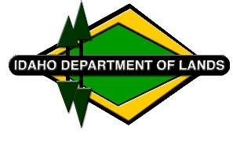
Vandals 1 Acquisition Fact Sheet

Idaho Department of Lands (IDL), as part of the State Board of Land Commissioners (Land Board), approved Strategic Reinvestment Plan, purchased almost 18,050 acres of timberland in five northern Idaho counties. The land was purchased using endowment proceeds from the sale of residential and commercial properties. The newly purchased timberland will be managed to generate revenue for public education and other endowments and remain open to the public for recreation.

Who sold the property?
The seller was Molpus Woodlands Group, representing the Carmona Tristar, LLC ownership group.

What was the total acreage and purchase price?
IDL acquired a total of 18,047.77 acres at an overall purchase price of $50,439,200.

Where is the land located?
The newly acquired timberlands are located in five northern counties and are adjacent to and intermingled with existing endowment timberlands. The following is a breakdown of the newly acquired timberlands and the associated tax impact by county:

County | Total Acres | Annual Taxes
Boundary | 3,216.52 | $6,779
Bonner | 4005.09 | $8,608
Benewah | 4,563.73 | $14,081
Shoshone | 6,222.43 | $16,584
Kootenai | 40 | $88
Totals | 18,047.77 | $46,140

What endowment beneficiaries now own the land?
- Public Schools 15,142.08 acres
- State Hospital South 1,118.96 acres
- Normal Schools (Lewis-Clark State College, Idaho State University) 1,786.73 acres

Where did the money to buy the land come from?
The money for acquiring timberland comes from endowment proceeds from the sale of residential and commercial properties. Proceeds from the sale of residential and commercial properties are deposited in the Land Bank for up to five years to be reinvested in timberland as approved in the Land Board’s Strategic Reinvestment Plan. No general or other state funds are used to purchase these lands.

January 18, 2023

