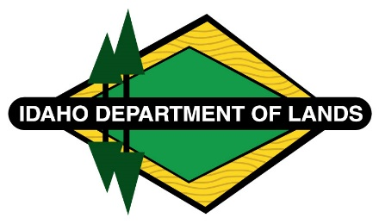

DISTRICT/ASSOCIATION NAME
Address, City, State Zip
Phone # Fax #

INSPECTION REQUEST FORM

Compliance Agreement #

Contractor Address

City State Zip Code

Phone Number Landowner

Date Last Load Hauled Total Volume Harvested

Locked gates or special instructions for access (animals, road closures, etc):

I request an inspection of the hazard abatement accomplished on this operation.

Printed Name

Signed Name Date

All inspection requests must be in writing, no exceptions will be allowed.

If slash will not be treated by the expiration date contact the Fire Warden as soon as possible to make alternate arrangements. If you do not, the monies may be forfeited and liability assumed.

Note: Within thirty days of receipt of an inspection request, an attempt will be made to make a field inspection. If weather conditions make inspections impossible, you will be notified. If more hazard abatement work is required, you will receive a copy of the Fire Hazard Management Inspection Report. After the operation passes inspection, the Release of Cash Bond is based on the date the last load of logs was hauled to a sawmill and the sawmill’s annual slash reporting schedule to the state of Idaho. Depending on the sawmill’s reporting schedule some bonds may take more than 90 days to release. Knowing the date of the last load of logs hauled to the mill and total volume will assist with processing.

