Version 1.0
2023
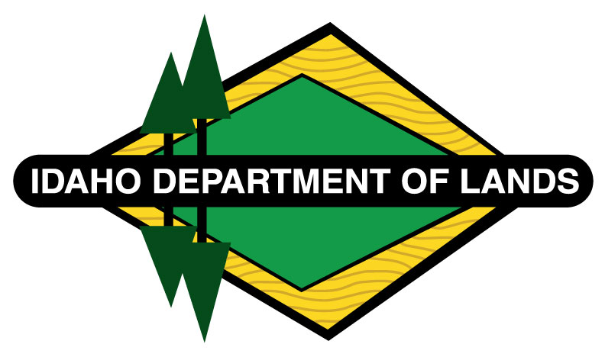

Idaho EAB Preparedness
City of <enter municipality here>
Acknowledgments
Template designed by:
Idaho Department of Lands Urban & Community Forestry Program
<List additional local credits here>
This project is funded in part by the Idaho Department of Lands in cooperation with the USDA Forest Service. In accordance with Federal law and U.S. Department of Agriculture (USDA) civil rights regulations and policies, this institution is prohibited from discriminating on the basis of race, color, national origin, sex, age, disability, and reprisal or retaliation for prior civil rights activity. (Not all prohibited bases apply to all programs.)
Program information may be made available in languages other than English. Persons with disabilities who require alternative means of communication for program information (e.g., Braille, large print, audiotape, and American Sign Language) should contact the responsible State or local Agency that administers the program or USDA’s TARGET Center at (202) 720-2600 (voice and TTY) or contact USDA through the Federal Relay Service at (800) 877-8339.
To file a program discrimination complaint, a complainant should complete a Form AD-3027, USDA Program Discrimination Complaint Form, which can be obtained online at https:www.ocio.usda.gov/document/ad-3027, from any USDA office, by calling (866) 632-992, or by writing a letter addressed to USDA. The letter must contain the complainant’s name, address, telephone number, and a written description of the alleged discriminatory action in sufficient detail to inform the Assistant Secretary for Civil Rights (ASCR) about the nature and date of an alleged civil rights violation. The completed AD-3027 form or letter must be submitted to USDA by:
- Mail: U.S. Department of Agriculture, Office of the Assistant Secretary for Civil Rights, 1400 Independence Avenue SW, Washington, D.C. 20250-9410; or
- Fax: (833) 256-1665 or (202) 690-7442; or
- Email: program.intake@usda.gov.

Cover photo credit: Jeffery Hahn Minnesota Extension Entomologist

Table of Contents
How to use this Template 4
Statement of Purpose 5
Introduction and Background 6
Biology and Lifecycle of EAB 7
Identification of EAB 8
Ash Identification Facts 10
Potential Impacts 11
Stakeholders & their Roles - Primary State Agencies 13
Readiness 15
Inventory 15
Risk Assessment (where is greatest risk?) 16
Estimate the Cost of EAB Infestations (Purdue) 17
Resilience 18
Resources Needed 20
Detection 22
Visual Survey 22
Monitoring 25
Branch Sampling 25
Branch Sample Tags 27
Trap Tree System 28
Attractor-Baited Traps 29
Rearing Cages 30
Response 31
Support and Expand Pest Detectors Program 31
Stakeholder Convention 31
Incident Command System 31
Investigation 34
Reporting 35
Report Findings from Branch Sampling Efforts 35
Origin & Dissemination 36
Delimitation 36
Management & Treatment 37
Tree Removal 37
Tree Preservation Efforts 38
Pesticide use in managing EAB 39
Trap Trees to Kill (bait & kill) 41
Long Term Management: Biocontrol 42
Funding 43
Appendices 44
Appendix A: Additional Resources 45
Appendix B: List of Approved Local Tree Services 46
Appendix C: Sample Specifications 47
Appendix D: Branch Sampling and Reporting 48
Appendix E: Sample Press Release 50
Appendix F: Organizational Flow Chart for Reporting (Example) 51
Appendix G: Sample EAB Inspection Form 52
Appendix H: List of Contacts for Reporting 53
Appendix I: Map of Idaho Communities where pest has been detected. 54
Endnotes/References 55

How to use this Template
The information in this document is consistent with the currently available knowledge regarding the Emerald Ash Borer and the effects this pest has on ash tree populations across the US. The base material contained herein is locked for editing purposes to keep instructions consistent for all users.
Content that can be edited to reflect the values and goals of each individual community is clearly marked using the “Highlight” feature.
Simply click in the highlighted area between the < angle brackets > and begin entering information specific to your community.
Use the Navigation Pane to move through the document easily. In the menu bar, select the view tab, and click on the “Navigation Pane” box.
The Table of Contents is Automatic. After adding your community’s specific information, click on the table of contents field at the top, select “Update Table” and click the “Update entire table” button, and select “ok”.
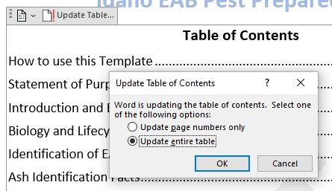
Plan Lifespan
This document is intended to act as a template for Idaho communities to Aid them in developing their own plans for detecting and managing Emerald Ash Borer and should be reviewed at minimum every five years to determine if changes need to be made and/or if information should be updated.

Statement of Purpose
The emerald ash borer (EAB) (Agrilus planipennis) has been devastating ash tree (Fraxinus spp.) populations all over the US. This invasive pest was first found in the vicinities of Detroit Michigan and Windsor Ontario back in 2002. However, because it can take years before the pest is detected, it is likely that it was introduced much earlier.
EAB can fly, but primary long-distance movement occurs via human transport of infested materials (primarily firewood and nursery stock). Speculations suggest that the pest was introduced via shipping materials. It has been suggested automobiles and other modes of transportation must also be considered a source of disbursement.
EAB is native to China, Mongolia, Korea, Japan, and Russia. Because Asian varieties of ash trees evolved alongside this pest, they developed a natural resistance, therefore EAB has only been considered a minor pest in its home range. The native ash trees in North America do not exhibit the same resistance as the Asian species, and because of this ash forests all over the US are expected to be destroyed as EAB’s introduced range expands.
Because ash trees have proven to be such hardy, tolerant trees well suited for growing in the often-harsh conditions of the urban environment, they have been planted extensively in landscape settings in many US Cities. Therefore, EAB has become a major threat to urban forests even in areas without native ash forests.
This destructive pest appeared in Colorado in 2013 and was discovered in Western Oregon in 2022 where Oregon ash (Fraxinus latifolia) occurs in riparian areas. It is only a matter of time before EAB begins to show up in Idaho communities.
This document is intended to serve as a template to help Idaho cities develop a plan of their own. Used in conjunction with the state of Idaho’s Response Plan for Invasive Insect and Disease Tree Pests, this template will help communities to be prepared when EAB arrives in their own municipality. The purpose is also to educate and encourage community decision makers and stakeholders, to elicit participation in prevention and readiness efforts, and to serve as a tool in helping to establish a framework for community action by outlining major issues and providing guidance on how to address them.
It has become critical that we prepare for the presence of EAB in Idaho. Having a preparedness plan in place ensures that your community will not be caught off guard scrambling to gather resources and come up with a last minute approach to dealing with a problem that can quickly spiral out of control and exhaust local resources.
This plan may serve as a model for protecting Idaho forest resources from other invasive forest pests and aims to ensure that Idaho’s urban forests continue to be diverse and resilient to climatic changes and other threats (fire, insects, disease, noxious weeds, etc.) and that the highest ecosystem benefits are identified, maintained, and enhanced.

Introduction and Background
The Idaho Invasive Species Council and Tree Pest Committee is a group of stakeholders consisting of representatives from Idaho’s state agencies, responsible federal agencies, partner institutions, tribes, and community officials that came together to develop a plan to respond to an invasion of exotic tree pests that include insects and diseases.
The council developed a document known as the “Idaho Response Plan for Invasive Insect and Disease Tree Pests” which is a supplement to Idaho’s “Strategic Action Plan for Invasive Species”. This preparedness template is a working document intended to be an extension of the Idaho Response Plan for Invasive Insect and Disease Tree Pests.
Idaho has diverse forests that provide many benefits to communities, and the Idaho Invasive Species Council and Tree Pest Committee has divided Idaho forests into two categories:
Urban Forest – is comprised of public and privately owned trees that are important assets to the cities where they grow. In fact, the trees that make up the urban forest should be thought of as part of the city infrastructure. If they are planned for and maintained properly, trees are the only municipal asset that appreciates rather than depreciates in value as they get older. Trees continuously provide benefits ranging from increased property values, reduced costs in energy consumption, savings in stormwater mitigation, jobs and more. The benefits that trees provide have been widely studied and established.
Rural Forest – Native forests cover over 40% of Idaho, with fewer than 15 native coniferous species and several deciduous hardwood species. The management responsibilities of these forests are shared among federal, state, industry, tribal, and other private ownerships. The timber industry in Idaho employs nearly 20,000 people and produces nearly $1 billion in sales of wood products.
Because such a vast portion of the forested lands in Idaho are comprised primarily of conifers, the potential for EAB transferring from urban areas into rural forests is limited, making the urban forests of Idaho the primary focus for this preparedness plan.

Biology and Lifecycle of EAB
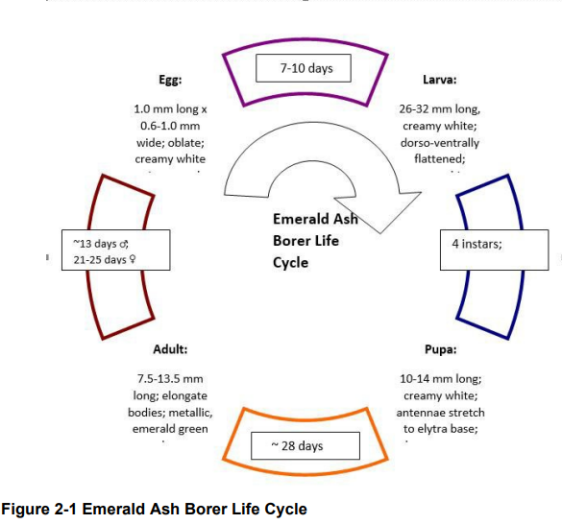
Image from USDA Emerald Ash Borer Program Manual 2015

The Emerald Ash Borer has four life stages: egg, larva, pupa, and adult. This is known as complete metamorphosis. EAB completes this process in either a one or two-year period. In healthy ash trees with a low population density, EAB tend to complete their life cycle in two years, while stressed trees that support higher population levels of larvae can host a one-year life cycle. Adult EAB begin emerging in mid-late May reaching peak emergence in late June, and females begin laying eggs approximately two weeks after emergence. After one to two weeks of incubation, eggs hatch and the larvae begin to burrow into the cambium layer of trees where they will feed for several months before overwintering. When spring comes, pupation will ensue, and a new generation of adults will emerge to repeat the process.

Identification of EAB
EAB has a “Complete” life cycle, egg, larvae (with 4 instars), pupae, and adult.
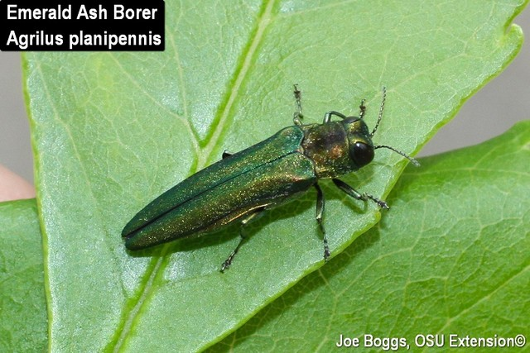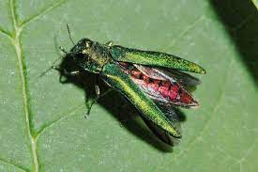
Photo credit: Jeffrey Hahn
Because the color of adult EAB can vary they are most easily recognized by the bright, coppery red dorsal surface of the abdomen beneath the wing covers. Adults are typically 7.5– 13.5mm in length.
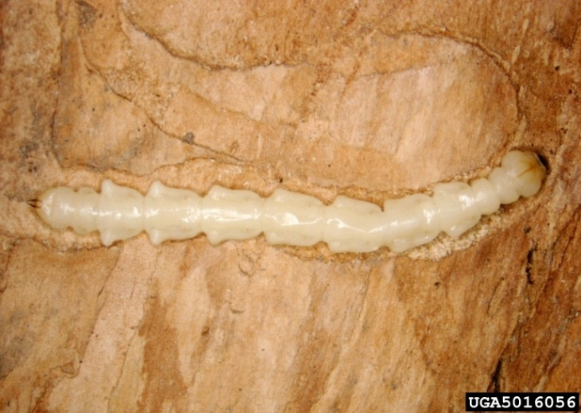
Photo Credit: Pennsylvania dept. of Conservation & Natural Resources – Forestry, Bugwood .org

EAB larvae are in the “flat-headed” borer family (Buprestidae), and therefore exhibit a somewhat flattened body. They go through 4 instar growth stages, reaching up to 1.5” (38mm) in length at maturity. EAB are most easily recognized by the “bell” shape of their segments and the posterior pair of small structures known as “urogomphi”. Larvae can be found in the sapwood of infested trees.

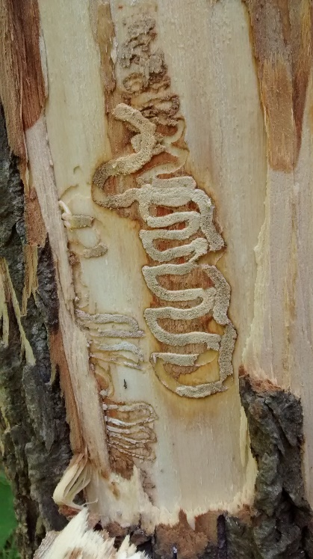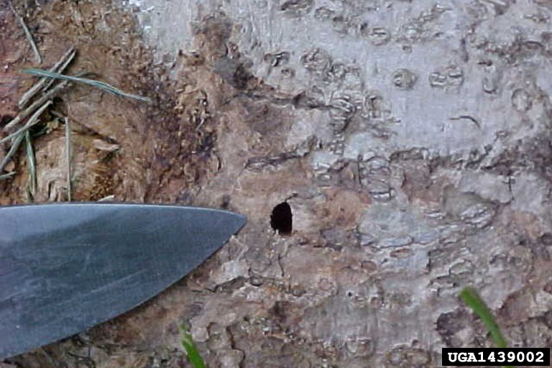
Photo Credit: David R. McKay, USDA APHIS PPQ
Photo: Tawny Simisky

EAB larvae make a distinctive “S” shaped, curved gallery as they feed in the cambium and one-to-two-year xylem (sapwood) of trees just below the bark. Pupae develop into adults within the tree, and then adults chew their way out of the tree to search for a new host. When adults emerge, they leave a characteristic “D” shaped exit hole that is 1/8 inch.
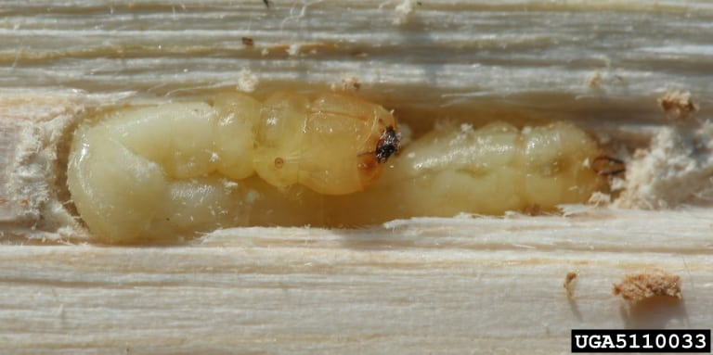
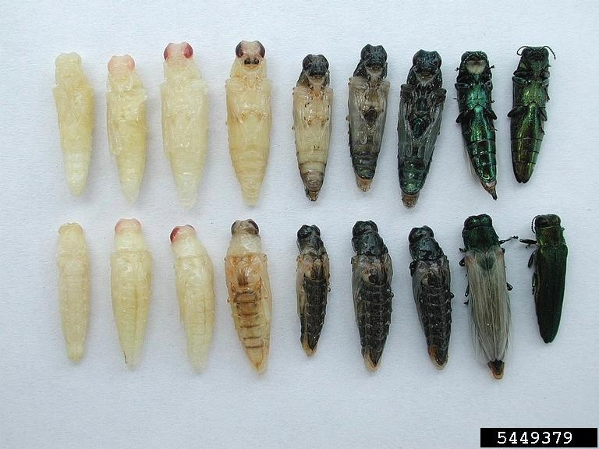
Photo source: Connecticut Tree Protective Association
Photo Credit: Debbie Miller, USDA Forest Service

The “pre-pupal” stage of EAB larvae position themselves in a “J” shape as they prepare to pupate in the sapwood. The pupae begin to take the shape of adults, beginning as a white cream color then gaining color as they develop. This pupal phase is usually completed in 5–28 days, with the adults emerging in the spring.

Ash Identification Facts

All ash (Fraxinus spp.) trees exhibit an opposite branching habit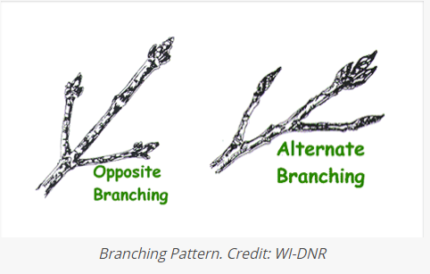
All ash (Fraxinus spp.) trees exhibit compound leaves consisting of 5–11 leaflets per leaf. 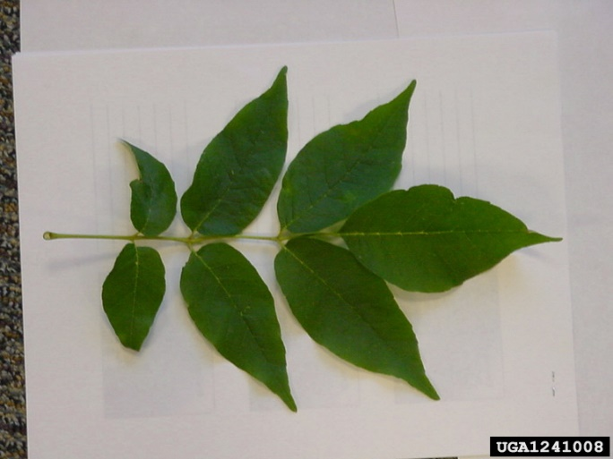
Photo Credit – Michigan Dept Ag. Bugwood.org
Tree bark is not always the best feature used to identify an ash tree. Especially given the variations between young and old trees, as well as the different species (Fraxinus americana, F. angustifolia, F. excelsior, F. latifolia, F. nigra, F. oxycarpa, F. pennsylvanica, F. quadrangulata)
An example of bark on mature white ash. Photo Credit – Keith Kanoti
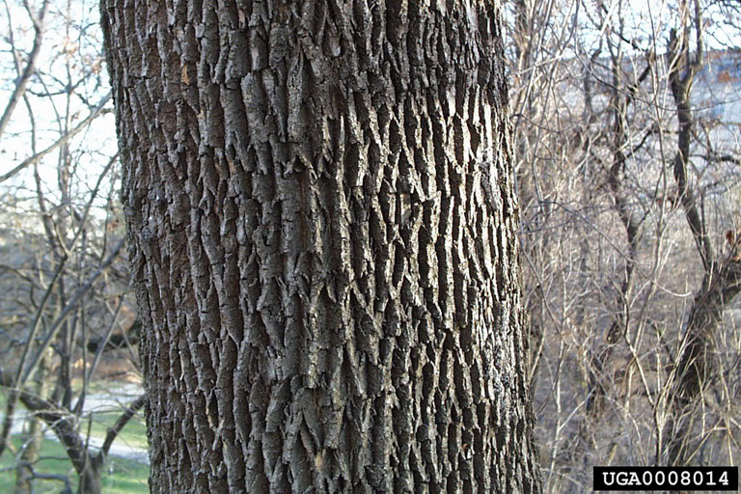
Ash trees (Fraxinus spp.) are mostly dioecious, which means that trees can be either male or female, but they do not usually produce both flower sexes on a single tree (except in some species).
The “fruit” or seed of the tree is a true samara, 1–2 inches long and 1/4 inch wide with the wing extending for about 1/3 the length of the body.
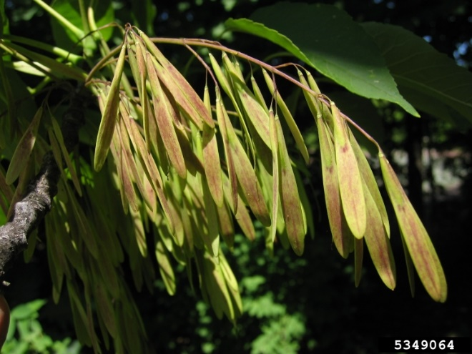
Photo credit – Keith Kanoti
Additional ash tree ID resources in Appendix A

Potential Impacts
Natural Areas, Wildlife and Water Quality
Idaho has no naturally occurring stands of ash trees in its forests. Therefore, the damage from EAB is expected to be limited to the urban areas where ash trees are commonly planted as landscape trees in city, county, or state-owned properties, parks, and on private properties.
In many of these urban areas there are also “greenbelts” that occur along stream banks. Some ash trees have become naturalized in these areas due to seed distribution. These naturalized trees have become important members of riparian and wildlife habitats, providing many benefits that span from stream bank stabilization, to shelter such as sites for nesting birds and roosting bats. The seeds (known as samara) can be an important food source for animals such as squirrels, mice, and birds.
In riparian areas, tree roots play important roles such as capturing/mitigating stormwater and nutrient runoff, as well as reducing the sediment load in streams that could be detrimental to aquatic animal species. If the ash trees in these communities were to succumb to EAB it may facilitate colonization of other invasive plants. The increase of standing and fallen dead ash trees could also alter soil pH when logs decompose, and the loss of canopy could result in increased water temperatures.
Economic Impacts
The costs associated with managing an EAB invasion are high and ongoing, with federal and state resource managers spending millions of dollars each year. In EAB infested areas where there are native stands of ash in the forests, the continued spread of EAB completely alters forest ecosystems.
Over 22 states and provinces in North America are currently spending millions of dollars annually to control the spread of the invasive Emerald Ash Borer, remove trees that have been killed and been made hazardous by the pest, and to protect or preserve trees that have not been killed in attempt to preserve the integrity of urban forests.
Ash trees have been one of the most popular landscape trees in urban forests due to their tolerance of a wide range of tough environmental conditions and can often make up close to 20% or more of the total population of municipal urban forest trees.
The estimated cost of treating, removing, and replacing millions of ash trees in urban and residential areas in the last decade in 25 states has been estimated at $25 billion. The nursery industry nationwide produces an estimated 2 million ash trees per year with average approximate values ranging from $50 to $70 per tree. This results in an annual ash nursery stock worth estimated at between $100 - $140 million.

Urban and Community Forests
Municipal areas in Idaho stand to suffer the biggest impacts from EAB establishment, with many urban tree inventories consisting of large percentages of ash trees.
Cultural Resources
In many parts of the country where native stands of ash exist, these trees have important cultural significance to the Native American tribes that used the wood of ash trees in basket weaving, construction of fish traps and weirs, and other ceremonial uses. In Idaho there are no native or naturalized populations of ash trees within our forests. Because of this, the primary focus has been on ash trees in urban communities.
Human Health & Safety
Urban trees contribute vastly to the “livability” of a city. The entirety of benefits that trees provide communities will not be fully discussed in this document, but it is important to highlight a few of the contributions that have the most immediate impacts on human health and safety.
Tree canopy impacts the ambient air temperatures of city environments reducing the urban heat island effect, tree roots intercept and filter ground water as it heads into our treatment facilities helping to lower the costs of operation, and trees filter the air helping reduce the levels of minute particles and allergens. Studies conducted in the Midwest by foresters and epidemiologists showed that the rapid loss of ash trees caused by EAB corresponded with an increase in mortalities related to cardiovascular and respiratory illnesses.
Standing dead trees left in the wake of EAB that have not been removed due to lack of funding or resources and/or falling limbs from dead and rotting trees pose direct, real, and immediate physical threats to public health and safety. (More about the risk associated with EAB killed trees in the section on Tree Removal.)
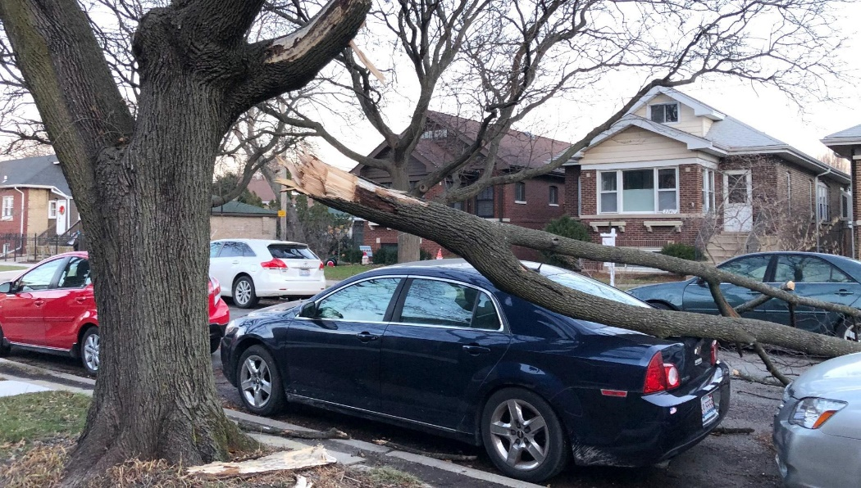
Photo credit Patty Wetli WTTW News Chicago

Stakeholders & their Roles - Primary State Agencies
Idaho Department of Lands (IDL) –
- Cooperates with state and federal agencies for detection surveys, to limit the spread of pests, and managing/responding to established forest pests.
  - Identifies and controls pests on endowment lands.
  - Educates forest industry, state land managers and landowners about forest pests.
  - Leads forest management, wood utilization, and restoration activities on state lands.
  - Seeks and applies for special funding and assistance through USDA Forest Service for established forest pests.
  - Assists with planning for solid waste disposal and/or utilization strategies.
  - Supports Idaho Community Forestry Program.
Idaho Fish and Game –
  - Assists other agencies with pest surveys on state lands and shares information.
  - Assists with public education about forest pests.
  - Cooperates with other agencies to manage forest pests on state lands.
Idaho Parks and Recreation – (undetermined what role this agency will play at this time)
Idaho State Department of Agriculture (ISDA) – Manages the inspection, export, and phytosanitary certification processes, manages inspection stations, conducts periodic pest surveys, and manages detection programs for agriculturally significant pests.
  - Conducts detection surveys of insects, plants, and pathogens.
  - Implements emergency measures at the state level to prevent the spread of pests significant to agriculture.
  - Provides laboratory support.
  - Provides information to the public and media.
  - Inspects and regulates the movement of nursery stock.
  - Issues and reviews interstate plant movement certificates
  - Reviews international and interstate plant and plant pest movement permits issued by APHIS.
  - Regulates pesticide use and registration.
  - Provides information to national pest reporting systems.
  - Administers state rules on intrastate movement of regulated materials.
  - Collaborates with USDA and other state and local agencies.
  - Represents Idaho on national and regional plant boards.
  - Designates and regulates invasive plants and plant pest species.
Other Principal Agencies and Partner Organizations
USDA Animal and Plant Health Inspection Service (APHIS) Plant Protection and Quarantine
- In 2021, APHIS discontinued funding surveys and trapping for EAB and is concentrating its efforts on biological control of EAB.
- Since much of eastern and midwestern North America is generally infested with EAB, the national quarantine on EAB infested materials was discontinued in January 2021. Any future quarantines would be implemented at the state or local level.
USDA Forest Service, Forest Health Protection (FHP)
- Evaluate and develop new technologies for pest management.
- Implement detection surveys, evaluation assessments and control measures on federal lands.
- Provide information and educational materials as appropriate.
- Provide additional funding through Cooperative Forest Health, Urban and Community Forestry or other programs to state and private organizations.
Idaho’s University System and Extension Service
- Share results of relevant research with state agencies
- Provide information through Extension, Master Gardener, Master Forest Stewards, and other programs.
Local Community Representatives and Officials
- Identify the local community or tribal contact, such as a City Forester or Council person to serve as a liaison for the community.
- Share tree inventory information, if available
- Cooperate with state agencies for detection surveys and response to pests.
Idaho Nursery and Landscape Association, Private Sector Professionals, Businesses, and Groups
- Cooperate with state agencies to disseminate information to members and clients about invasive pests and current status.
- Help identify businesses that may be directly impacted.
- Help identify certified arborists, foresters, and state certified pesticide applicators for management actions.
- Cooperate with state agencies for detection surveys and response on their property.
- <Enter other Local stakeholders here>

Readiness

Inventory
Complete inventories of ash throughout Idaho –
The Idaho Department of Lands (IDL) maintains a license with PlanIT Geo to use the TreePlotter™ Inventory database. IDL Urban & Community Forestry (UCF) Program has worked closely with PlanIT Geo to offer a version of the cloud-based Tree Plotter Inventory system to municipalities, counties, and universities/colleges throughout Idaho to create tree inventories to help them plan and manage their urban forests, this service is free of charge.
As of June 2022, there are 51 Idaho cities that have base information loaded into Idaho TreePlotter™, but only 34 of those communities have an active/ongoing inventory. To build an effective inventory-based pest preparedness plan, each of the participating communities needs to update their inventory database with the most current, accurate information.
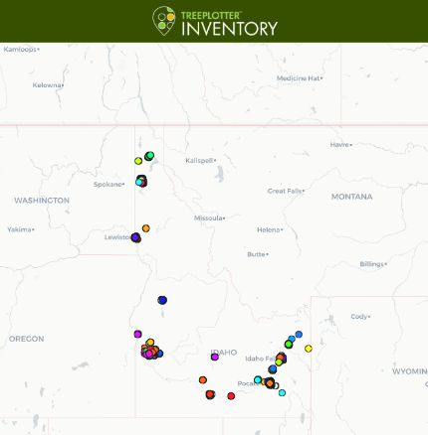
This is a powerful tool that all Idaho cities should take advantage of using. Training opportunities and in some cases even additional funding can be provided through IDL to assist communities with creating and updating tree inventories. Contact the IDL UCF Program Manager to learn more about obtaining access to this valuable resource.
Using TreePlotter™ a city can map out where all the ash trees are within their jurisdiction, assess condition, assign value, and prescribe management practices.
Creating and maintaining an inventory of at-risk trees is a critical first step towards the success of a management plan and being prepared for invasive pests like EAB.
The TreePlotter™ program for Idaho can be accessed here: https://pg-cloud.com/Idaho/

Risk Assessment (where is greatest risk?)
Risk of Imported Firewood
The greatest risk to ash in Idaho’s urban forests is from transportation of infested ash firewood from other infested neighboring states. Since the state of Oregon (with its own native Fraxinus) is now infested, the likelihood of introduction into Idaho is much greater. It is also speculated that EAB readily moves through “hitchhiking” on transportation such as automobiles or train carriages.
Fortunately, ash trees do not make up any large part of forest tree populations in Idaho, so the risk of urban trees becoming infested from firewood is minimal. It would be more likely that firewood from a previously infested ash tree in the urban environment that was removed due to infestation would pose a threat to ash tree populations elsewhere in the urban vicinity. Therefore, if a given area is known to have an infestation, then it would be prudent to develop local quarantine restrictions on the movement of ash wood between infested and non-infested areas.
Educate Groups about Awareness
Stakeholders have already begun educating professionals in the landscape & arboriculture industry, the public, gardening groups, and city and government officials who are in decision making positions. It is critical that these efforts continue and broaden among Idaho communities.
Idaho Department of Lands (IDL), Idaho Nursery Landscape Association (INLA), and Idaho Pest Management Association (IPMA) put on multiple education and preparedness presentations and training workshops for Landscape and Tree Service Professionals. Contact any of the stakeholders for more information about education events in your area or if you would like to schedule a class/presentation for your community.
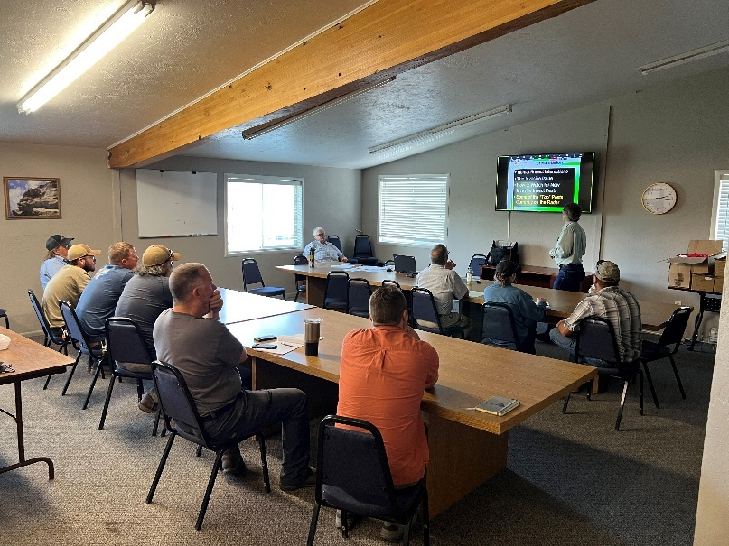

Estimate the Cost of EAB Infestations (Purdue)
The cost associated with EAB infestations can be staggering, depending on the percentage of urban canopy that is occupied by ash trees. According to data collected in the Idaho TreePlotter™ inventory some communities in Idaho have a tree canopy that consists of over 15%. This figure only represents trees that have been inventoried and does not include trees that exist on private properties.
Because the EAB has become so well established in other parts of the country, and other states have already been battling this pest for years, there have been a lot of lessons learned about how to monitor and plan for the damaging effects this pest will have on the communities where it arrives.
One excellent resource for evaluating the cost of EAB reparations has been put together by Purdue University Indiana. A current inventory of ash trees, number and sizes are needed to perform accurate calculations, as well as estimated cost of removal and replacement.
https://int.entm.purdue.edu/ext/treecomputer/
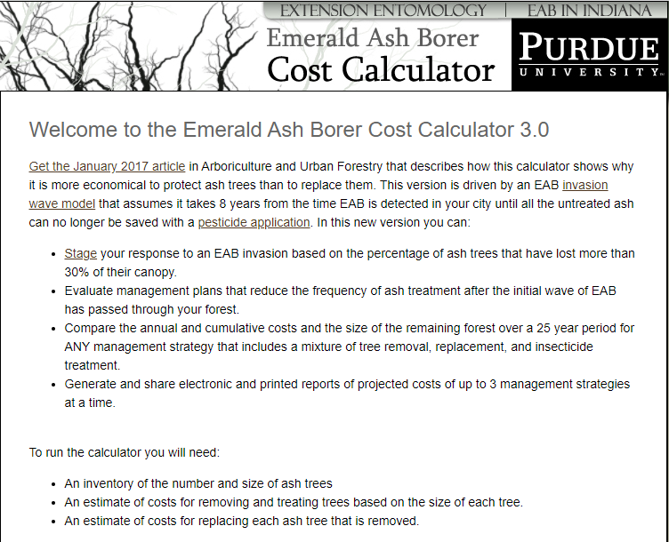

Resilience
The capacity of an urban forest to recover from EAB can be planned for by considering several different factors.
Because all North American ash species are susceptible to EAB an effort should be made to limit the continued use of these trees in future plantings. This is a task that has proven to be difficult, as many tree nurseries still grow these trees and sell them to the public, developers, and homeowners associations. Therein lies an opportunity for outreach education, and for municipalities to update development codes and include verbiage that discourages or even prohibits the planting of ash trees in new developments.
Municipalities are strongly encouraged to work closely with tree nurseries who may be operating within the area to provide alternative species for planting and discouraging the continued use of at-risk species.
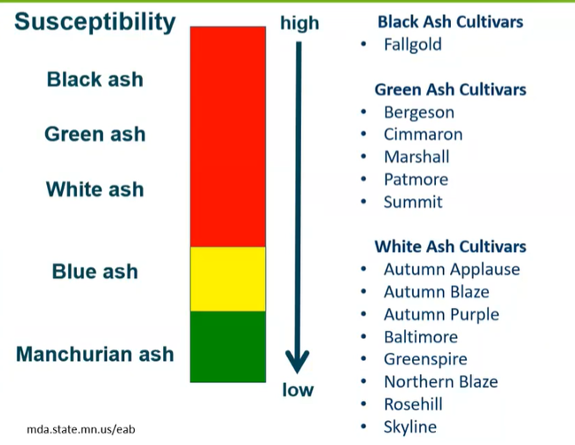
From Minnesota Dept of Agriculture
Tree diversity is an important aspect of any urban forest, and a commonly accepted practice in the urban forestry industry is the 10/20/30 rule. In this rule, it has been suggested that to sufficiently protect the health and longevity of an urban forest, the total percentage of a tree inventory should consist of no more than 10% of any one species, 20% of any one genus, or 30% of any one family. Some recommendations go so far as to suggest that genus is the factor that matters most, and no single genus should make up more than 5% of an urban forest canopy.

Native & Resistant Tree Seed Collection and Storage
The US Forest Service (USFS) and the Ecological Research Institute have been working with other collaborators to find and preserve trees that have survived the EAB outbreak.
These trees, referred to now as “lingering” ash, are thought to hold a key to further developing natural resistance in ash trees native to our forests in the US.
There is room for consideration of preserving trees that have exhibited partial or whole resistance. Seeds can be collected from these trees and stored for future planting and breeding efforts and/or cuttings can be taken from the trees for propagation uses. Cross pollination efforts can also be made to try and promote or encourage further resistance.
The “Monitoring and Managing Ash” project web page can be found at the following link as a resource; https://www.monitoringash.org/lingering-ash-info/

Preemptive Removal of Ash
The more that is learned about how destructive the Emerald Ash Borer has been for urban and forest ash tree populations across the US, the more one might be inclined to go out and start to proactively remove Ash trees throughout the city. This could even potentially create an opportunity for kickstarting an effort to increase the diversity among existing canopies.
For communities with small populations of ash trees, or where most ash trees are in poor condition and smaller in size, this may be an acceptable practice but will undoubtedly be a costly operation. This may also be a viable option for a private land or a homeowner who does not wish to endure the headaches that are certain to come with an EAB infestation.
In many cases, Idaho communities have high populations of ash trees in their urban forests, and many of them are large.
Instead of planning to remove all ash trees, consider some of the most effective measures that have been developed for detecting and monitoring EAB; these are mentioned in this plan in the Detection and Response sections as well as the section on Management & Treatment.

Resources Needed
<Use this section to create a list of resources that will be needed to implement a plan>

Pesticide Use & Applicators
Professional pesticide applicators are a valuable resource for any municipality. These are the professionals who are trained to recognize the signs and symptoms of damaging and invasive pests, they know which pesticide formulations are safest and most effective in managing infestations, and they know which methods to use to apply products safely according to federal and state regulations.
Professional applicators are required to seek continued training and updates on the safe use of pesticides. Stakeholders will work together to make sure these training opportunities are offered regularly to applicators, teaching the most current, and effective methods of control so they can be prepared to help mitigate the potential devastating effects of an EAB infestation. (See also “Pesticide Use in Managing EAB” for pesticide recommendations)

Tree Removal Resources
Some municipalities may be too small or may not have the funding to have their own Community Forestry Department and/or the equipment and resources needed to carry out the removal of infested, killed, or at-risk trees.
“Appendix B” can be used to create a list of local tree services your community will be working with for ash tree removals.
<Use this section to describe your Urban Forestry Department or list the local contractors you will be working with in your community.>
(If you will be working with contractors, be sure to provide them with specifications for how to dispose of wood properly) See page 21 and/or Appendix C

Wood Waste Disposal & Treatment

When trees that are infested with EAB are removed, it is important that the wood is disposed of properly so as not to act as a brood source. Cities should work with local contractors, waste facilities, and/or lumber yards to identify sites where wood storage requirements can be safely met.
<List potential sites for marshalling yards and/or wood storage and disposal here>
  - Chipping
All wood chips produced from the removal of infested ash or at-risk trees need to be ground down to sizes no larger than 1” by 1”.

  - Debarking
All trunk/stem pieces that are to be stored for later use as lumber shall have the bark and a minimum of 1/2” up to 1” of sapwood completely removed to prevent the wood from becoming infested with EAB larvae. (This may present a challenge for many holding sites as the equipment for performing these actions may be difficult and/or expensive to come by). Infested wood may also alternatively be stored if buried at least 1 foot below soil.

  - Heat
Green lumber, logs, and firewood require kiln sterilization or heat treatment in an APHIS approved facility. Treatment should consist of exposure to 60 degrees Celsius/140 Fahrenheit for at least 60 minutes. There are no APHIS approved facilities in the state of Idaho, therefore it must be a priority to emphasize chipping and debarking efforts.

    - Biochar is another alternative option for treatment of infested wood. Converting wood into biochar requires the use of an “Air Curtain Incinerator”. Annual permits for using/licensing this kind of equipment can cost as much as $10,000, which is a major barrier to overcome if this is to be a viable option.

Additional resources for planning an Urban Wood Disposal and utilization Program Here: https://urbanforestrysouth.org/resources/library/ttresources/community-urban-wood-utilization-planning-worksheet

Detection
The emerald ash borer has become well established in many US cities. Since 2002 the battle over protecting and preserving ash tree populations has been fought, and there have been many strategies developed that have proven to be effective in helping to manage and minimize the damage that is sure to be caused by this pest. This section will outline some of the most effective methods for detecting and responding to the arrival of EAB.

Visual Survey
This is the most basic form of detection and can be performed by anyone who has been trained to know what symptoms to look for. The problem with using this form of detection is that EAB can be present and active in a tree for multiple years before these symptoms begin to appear. Often, by the time these signs show up there are no measures other than removal that can be taken.
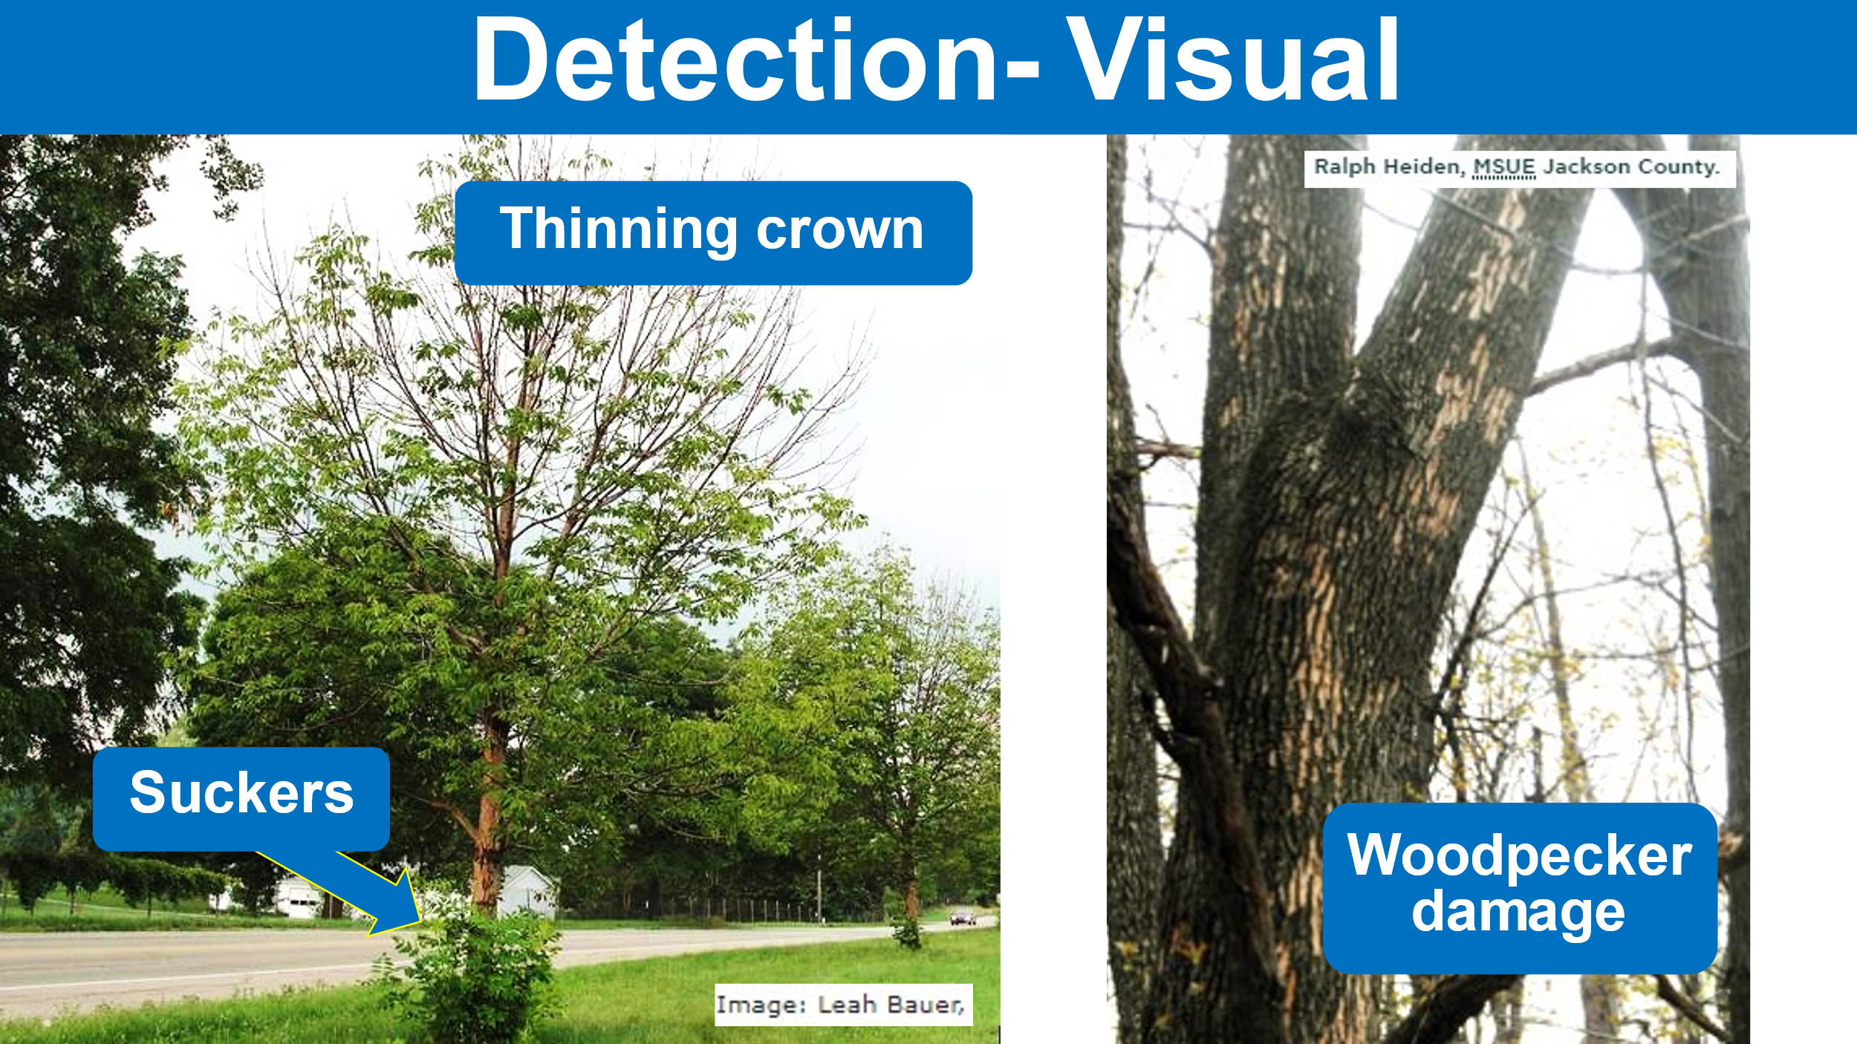
Thinning beginning in the upper portions of the crown, and the presence of epicormic shoots can be a sure sign that the pest is present and has caused significant damage. Combine these symptoms with the presence of woodpecker damage and the alarm bells should be ringing.
Woodpecker damage in EAB infested ash trees is often referred to as “blonding”, because as the birds are looking for larvae to feed on, they flake off the outer bark exposing a lighter color.

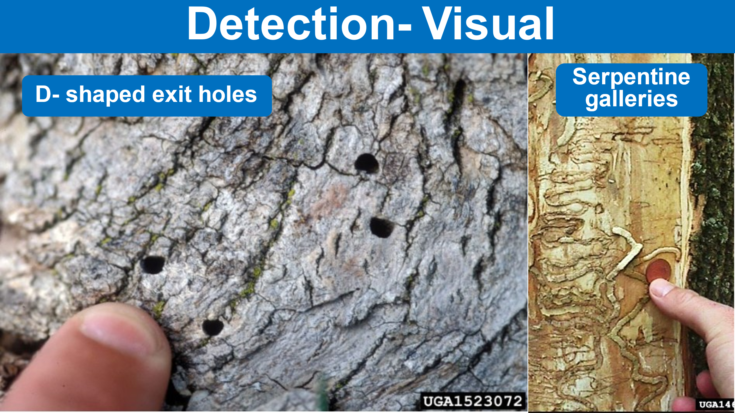
Photo credit James W. Smith USDA APHIS PPQ Bugwood.org
Photo Credit Daniel Herms, Ohio State University
“D” shaped exit holes are caused by adult EAB as they emerge from infested trees. The problem with using these as a detection method is that they are small, and often hard to see, especially if observations are being made from the ground. This detail should be used more as confirmation of the pest’s presence.
There are other boring insect pests that feed on and cause damage to ash trees as the larvae feed under the bark and make “galleries”, or cause exit holes as they emerge as adults (ex. lilac ash borer Podesesia syringae). The EAB is the only pest that makes “serpentine ‘S’ shaped galleries” in the cambium and sapwood of ash trees.
These visual detection strategies are not the most effective methods, because they are not very good for early detection, but they are easy to do, can be done throughout the year, and can be performed at the same time as an inventory.

Vertical Lesions/ Bark Splitting
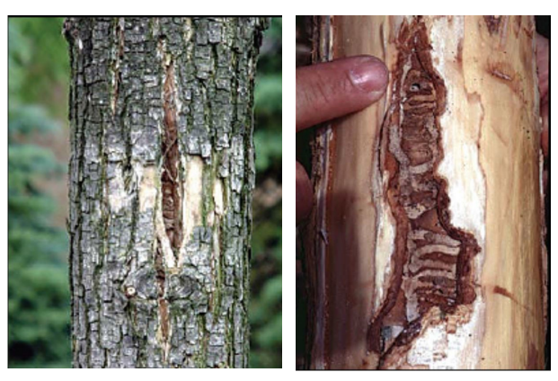
Another important indicator of the presence of EAB is “vertical” bark splits where damage from the feeding of the larval stage has occurred, and the tree is attempting to compartmentalize the wound. If these splits are found, check for the distinctive “S” shapes galleries that EAB makes.
Image from USDA Emerald Ash Borer Program Manual

Professional Assessment – Professional Arborists, Horticulturists, Applicators, and Landscape Maintenance workers are on the front line of this battle and should be trained and be familiar with these detection strategies. When they are called upon by homeowners to come inspect or do work on their trees, they know what to look for, and who to report to if EAB is detected.

Monitoring
*Note – Photos and procedures in this section from Natural Resources Canada Frontline Forestry Research Applications Publication Canadian Forest service- Sault Ste. Marie Technical Note No.111 K.L. Ryall, J.G. Fidgen, J. J. Turgeon

Branch Sampling
This highly recommended method of detection/monitoring has proven to be one of the most effective measures in early detection of Emerald Ash Borer. Often, infestations can be detected before visual symptoms show up in trees. Branch Peeling can be done throughout the winter, best if sampled between September and May. It is nondestructive and can be performed in conjunction with a regular pruning maintenance schedule.

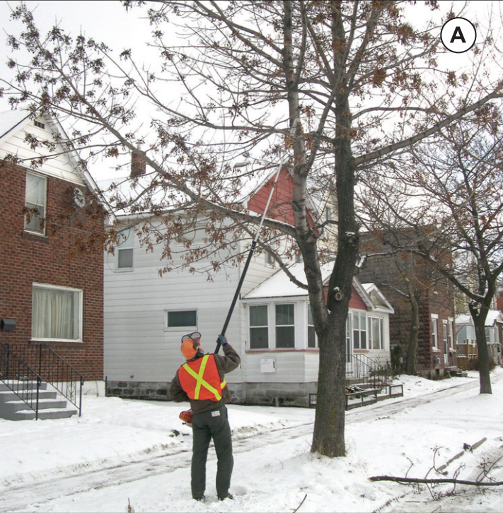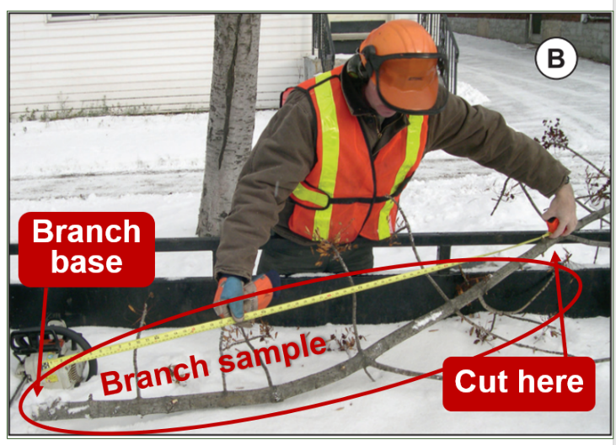
- (A) Select ash trees that are approximately 20–60 feet tall, 6–20” DBH
- (A) Prune two live branches (2–3” diameter preferred) from the south/southwest side of the mid-crown of the tree
- (B) Measure 30” from base of the branch and cut at 30” mark, use this portion as you sample piece
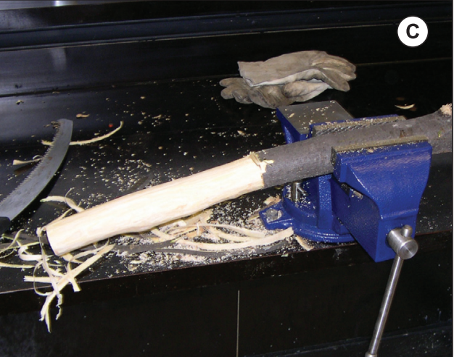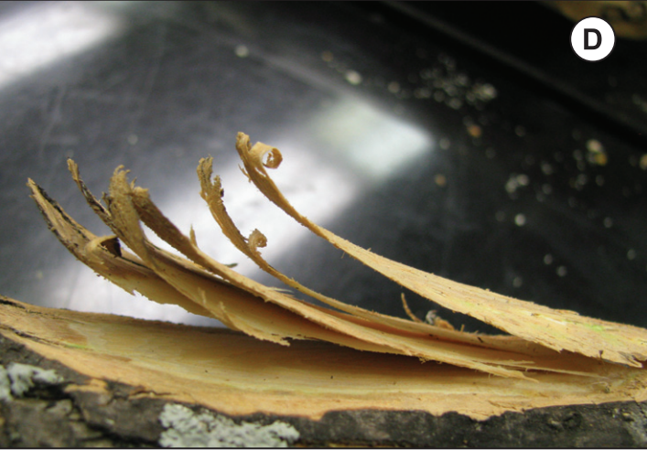
- (C) Secure the sample in a vise
- (D) Carefully whittle into the sapwood with a sharp draw knife or paring knife
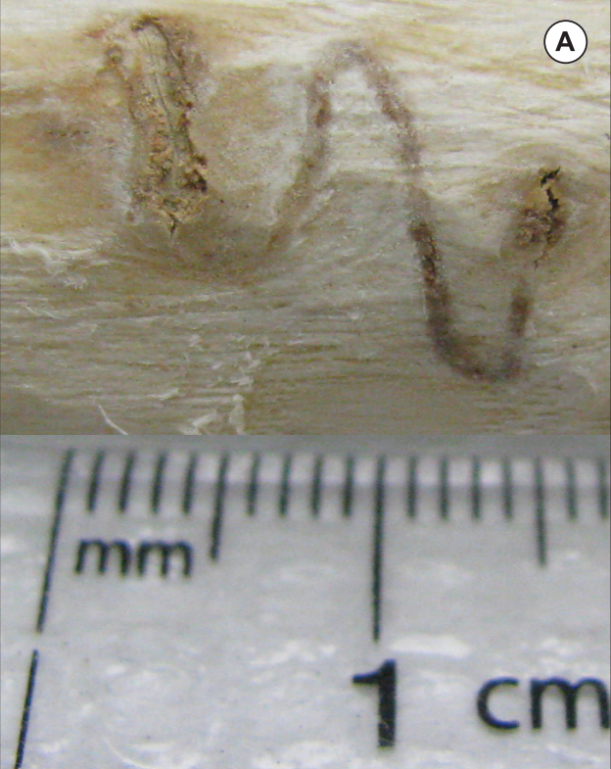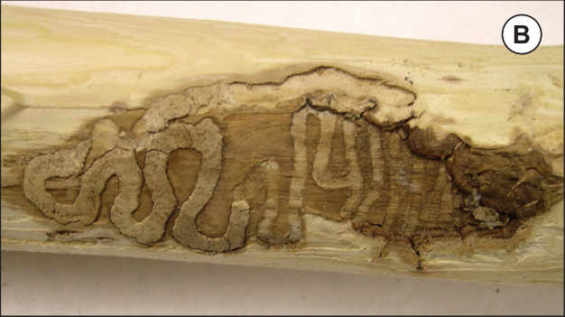
- (A) An early-stage gallery - as you whittle away be looking for galleries and/or EAB larvae in the phloem and the sapwood
- (B) A late-stage gallery in the sapwood
When conducting this strategy, it is ABSOLUTELY CRITICAL to remember to label your branch samples while collecting with an address etc. as you go so that you can recall exactly where they came from in case you discover evidence of the pest.

Branch Sample Tags
IDL has created a special tag that can be used to attach to Branch Samples during collections. To request a batch of tags please reach out to IDL Forest Health or UCF and these can be supplied free of charge. You can also print out your own labels to be used while collecting samples.
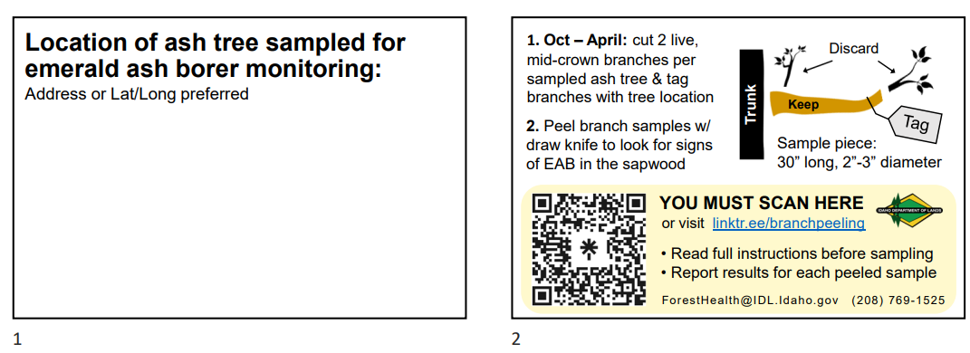
See Appendix D: Branch Sampling and Reporting for FAQs and information about how to report the results of your branch sampling and inspections.
Where can I find more information?

Please visit the Idaho emerald ash borer resources page: https://linktr.ee/eabinfo.idl
or contact the Idaho Department of Lands Forest Health Program
ForestHealth@IDL.idaho.gov or (208) 769-1525

Trap Tree System
When trees are stressed, they emit volatile organic compounds that EAB can sense, and EAB will preferentially attack stressed trees before healthy, vigorous trees. We can use this knowledge to our advantage and set up trap trees (intentionally stressed trees that will be highly attractive to EAB) to monitor for the arrival and/or presence of EAB.
The Trap Tree system is a very effective way to monitor low density populations of EAB. This method can also be used as a great opportunity to educate the public about what you are doing and how to keep an eye out around their own property. Put a sign on Trap Trees to inform the public of what you are doing.
Because this method ultimately results in the death of the tree, you will want to select trees that are:
- Already planned for removal. (Trees should be removed in fall and can be inspected for presence of EAB at time of removal.)
- Near high-risk areas such as log yards, dumps, developed camp sites, or in areas with poor growing conditions and no irrigation.
- In areas with a high density of ash.
- In high value areas where intervention will be important.
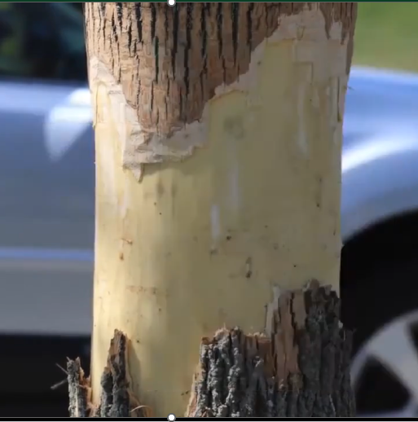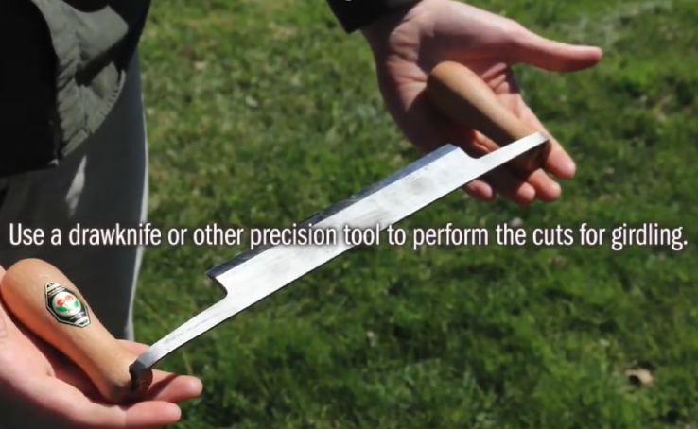
Select a tree that is 4–10” DBH (Larger trees can be used but are more work). Trap Trees should be set up in the spring between mid-May and early June while the bark is “Slipping”, and care should be taken to make sure you do not cut into the sapwood (Xylem). If this happens the tree will die too quickly and will be ineffective as a Trap Tree. Remove an 8–10” section of the bark from the lower stem or at breast height effectively girdling the tree.
Remember to remove Trap Trees in the fall. If EAB is present in the area they will be attracted to these trees, and if the Trap Trees are not removed, then the pest will be allowed to proliferate. If using Trap Trees in your monitoring, it is recommended that you also apply the “Trap Trees to Kill” method. (See Trap Trees to Kill section under Management and Treatment in the Pesticide Use in Managing EAB section.)

Attractor-Baited Traps
APHIS will no longer coordinate trapping programs, so these efforts would need to be run by state and local entities.
The use of attractors and baited traps has not proven to be a very effective tool for managing EAB. Although traps can be used as an educational tool and they may be able to tell if a pest is present in an area, they are not very good at early detection, and they won’t tell you which trees are infested. Traps can be messy and troublesome to handle, they can be vandalized easily, and samples can be damaged, and lures often require storage in a non-food freezer.

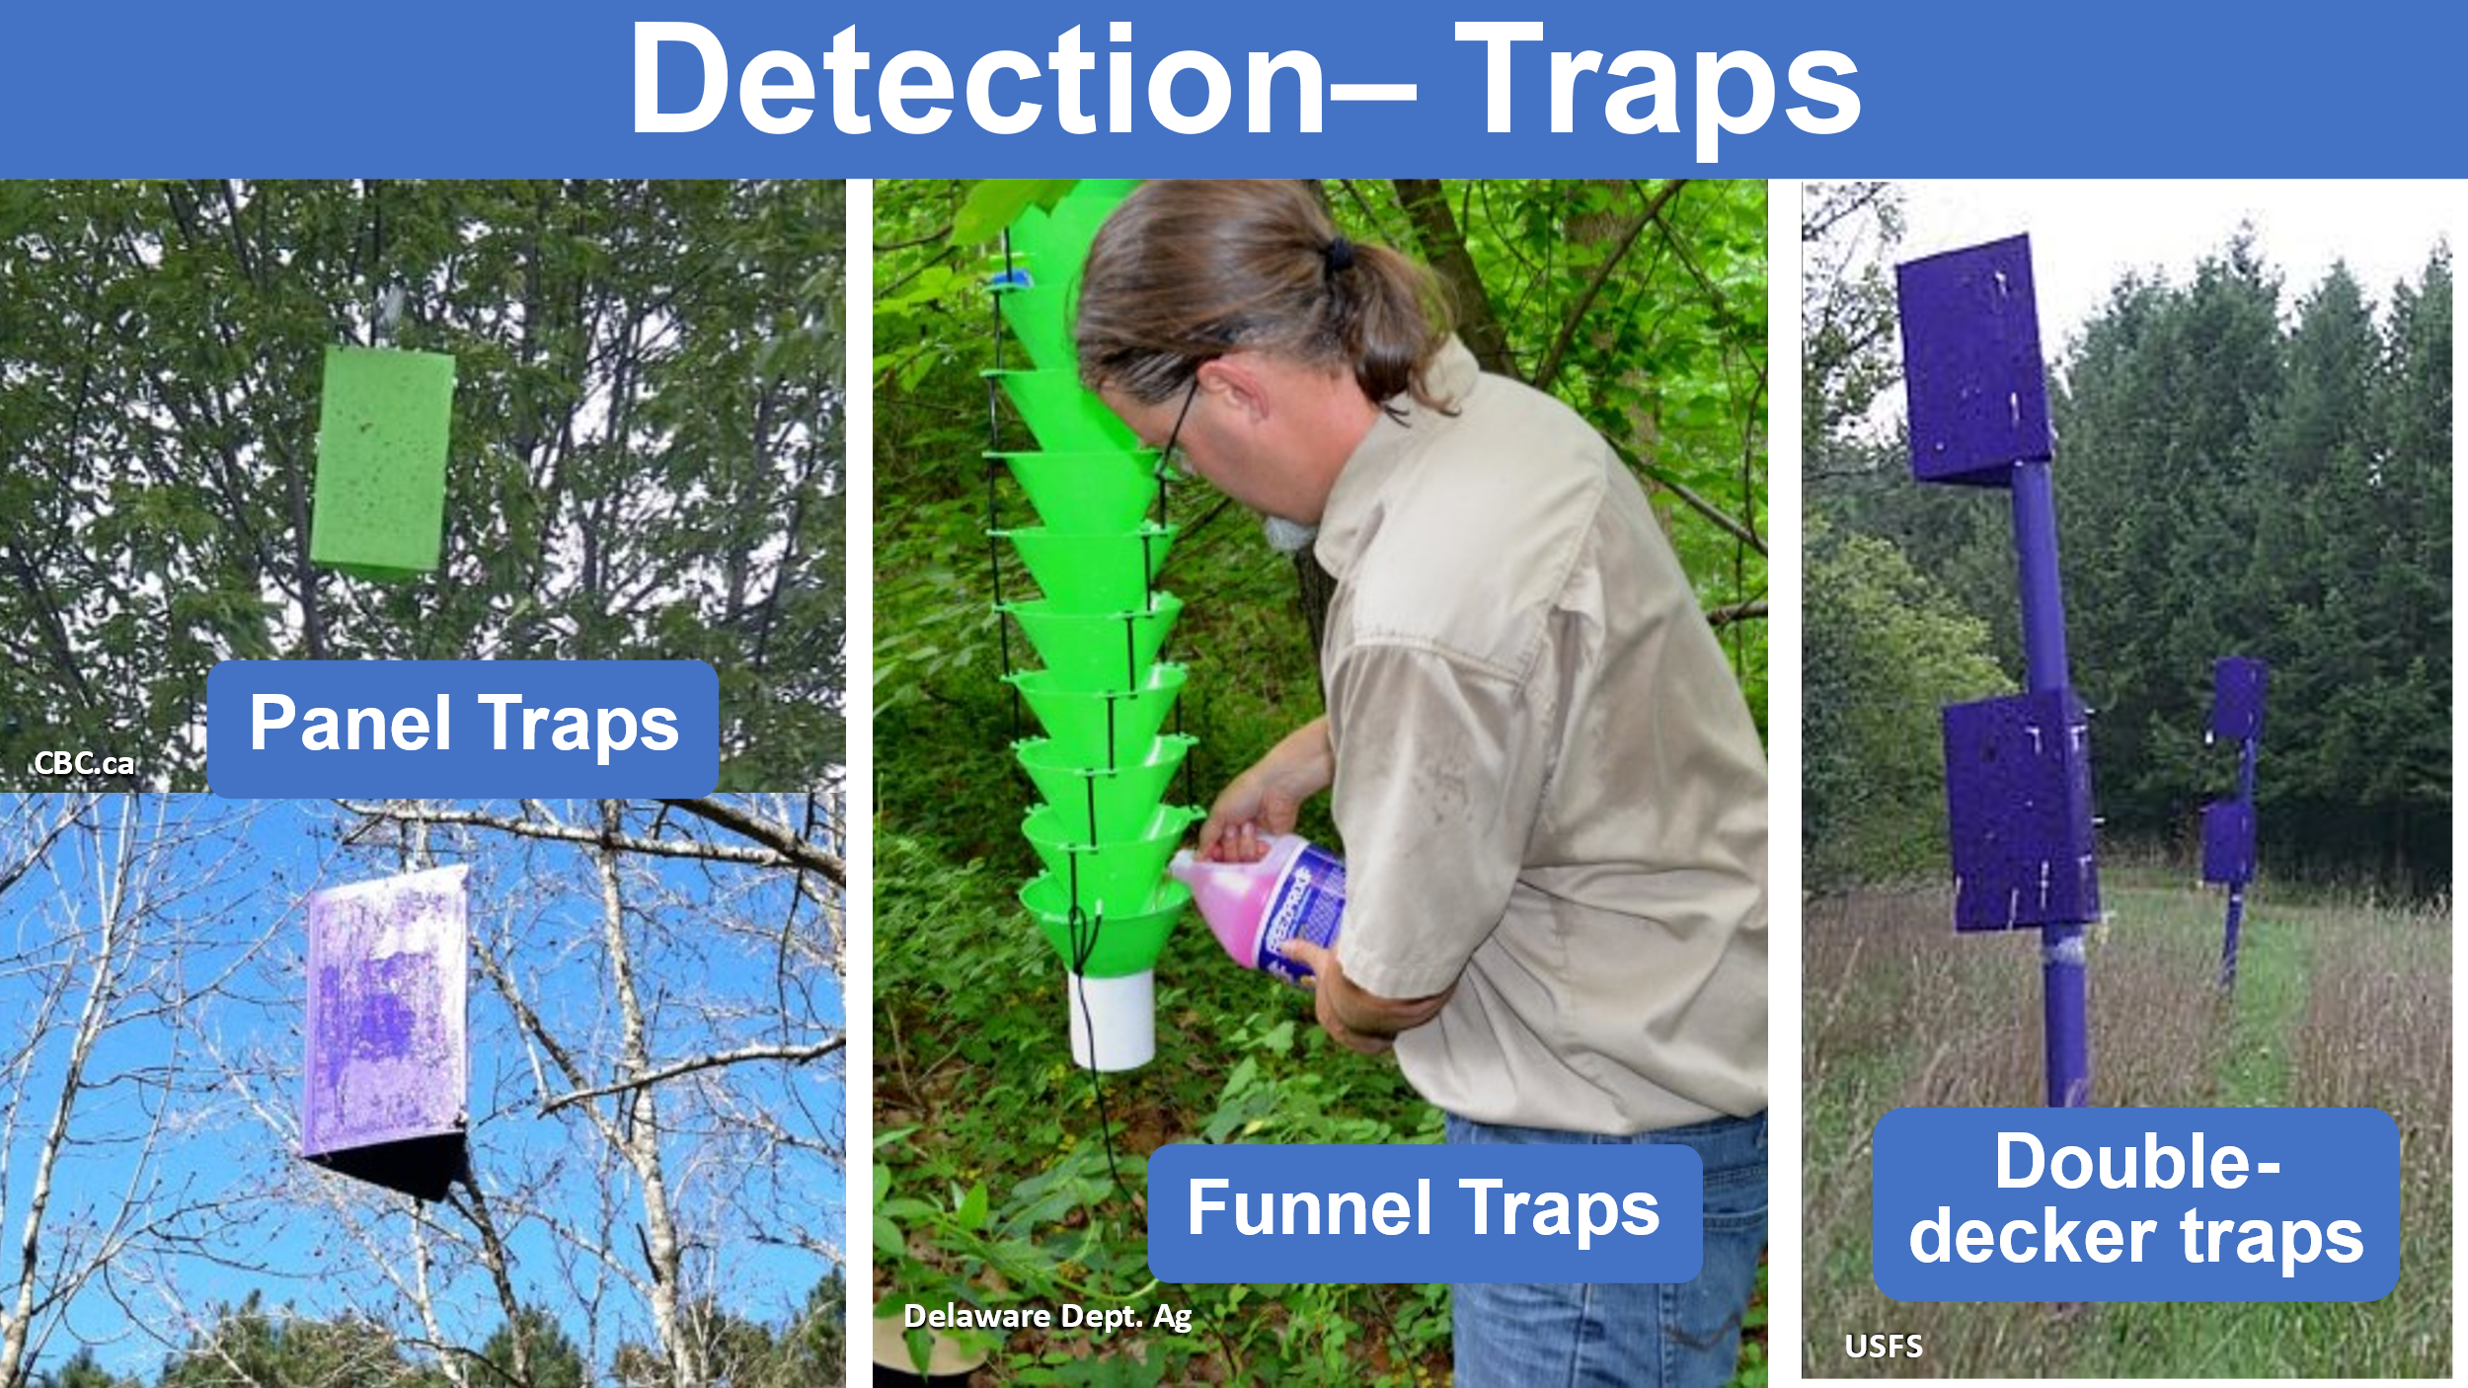

Rearing Cages
Once EAB has been found to be in an area, and infested trees have been identified another tool for monitoring EAB activity that can be useful is “Rearing Cages”. The use of Rearing Cages is more practical for universities & state agencies.
This is the concept of collecting samples from trees that are thought or known to be infested and storing samples in an enclosed space where they can be regularly checked and monitored for the presence of pests to learn more about the timing of pest emergence in your local area. Rearing Cages could also be used as a passive form of monitoring instead of branch sampling.
Rearing Cage design can vary, they can be ordered online, or customized by building your own. Storage space will need to be set up, preferably outside in a yard where the samples can be subjected to light and temperature fluctuations.

Because the lifecycle of EAB can sometimes be as long as two years, having a place to store Rearing Cages out of the way where they will not interfere with daily operations will be necessary. Cages will need to be checked regularly throughout the season from April – September, it is recommended they are checked at least on a weekly basis.
Depending on the design of the cage it can be difficult to shift samples around and inspect them, if you use this system be sure to keep this in mind.
When using this system, it will be critical to label samples to document where they came from.
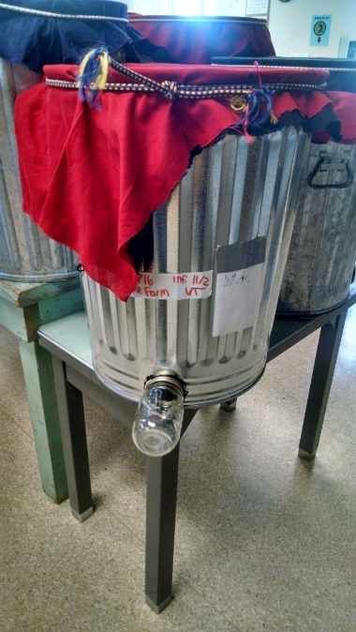
Rearing Cages can be a valuable tool to gain a better understanding of the life cycle and emergence of EAB.

Response

Support and Expand Pest Detectors Program

Stakeholder Convention
Organizing a meeting of all stakeholders will be crucial to a successful program. When all entities who will be involved in response are brought together at the same table, a plan can be communicated clearly to make sure everyone is familiar with the system that is put in place, and everyone is on the same page.
Make sure there is coordination between all local governing bodies, and that landowners and tribes are included and/or given a seat at the table.
<Add a plan for meeting with local stakeholders here>

Public Engagement
It will be important to set up a good system to engage the public and increase awareness. This can be done through multiple modes of delivery. A good start would be to make a public service announcement, using the internet, radio, newspapers, mailing out handbills, billboards, and even television. It will be critical to cooperate with local news sources who can help get the word out.
A sample public announcement for your use can be found in Appendix E.
<Enter your plan for a Public Awareness campaign here>

Incident Command System
When all potential local stakeholders have come to the table, and an agreement has been reached on how to respond to the arrival of EAB in your area, a chain of command must be created to establish who will be responsible for reporting findings and who will they report to. In times of critical incidents such as an invasive pest outbreak, it will be important to maintain an organized structure to avoid confusion and a breakdown in communication. It will be important to have a system for dealing with calls reporting potential discoveries.
Creating a flow chart to help with a systematic approach to management is a good idea. A sample template is provided for your use in Appendix F to help organize your system for Collection, Identification & Verification. This is only a sample, it may be necessary to build out the structure and make it more comprehensive, based on the needs of each community.
On the following page are some examples of how a flow chart or decision matrix may be set up for your community operations, along with some questions to consider when building your chain of command reporting sequence.

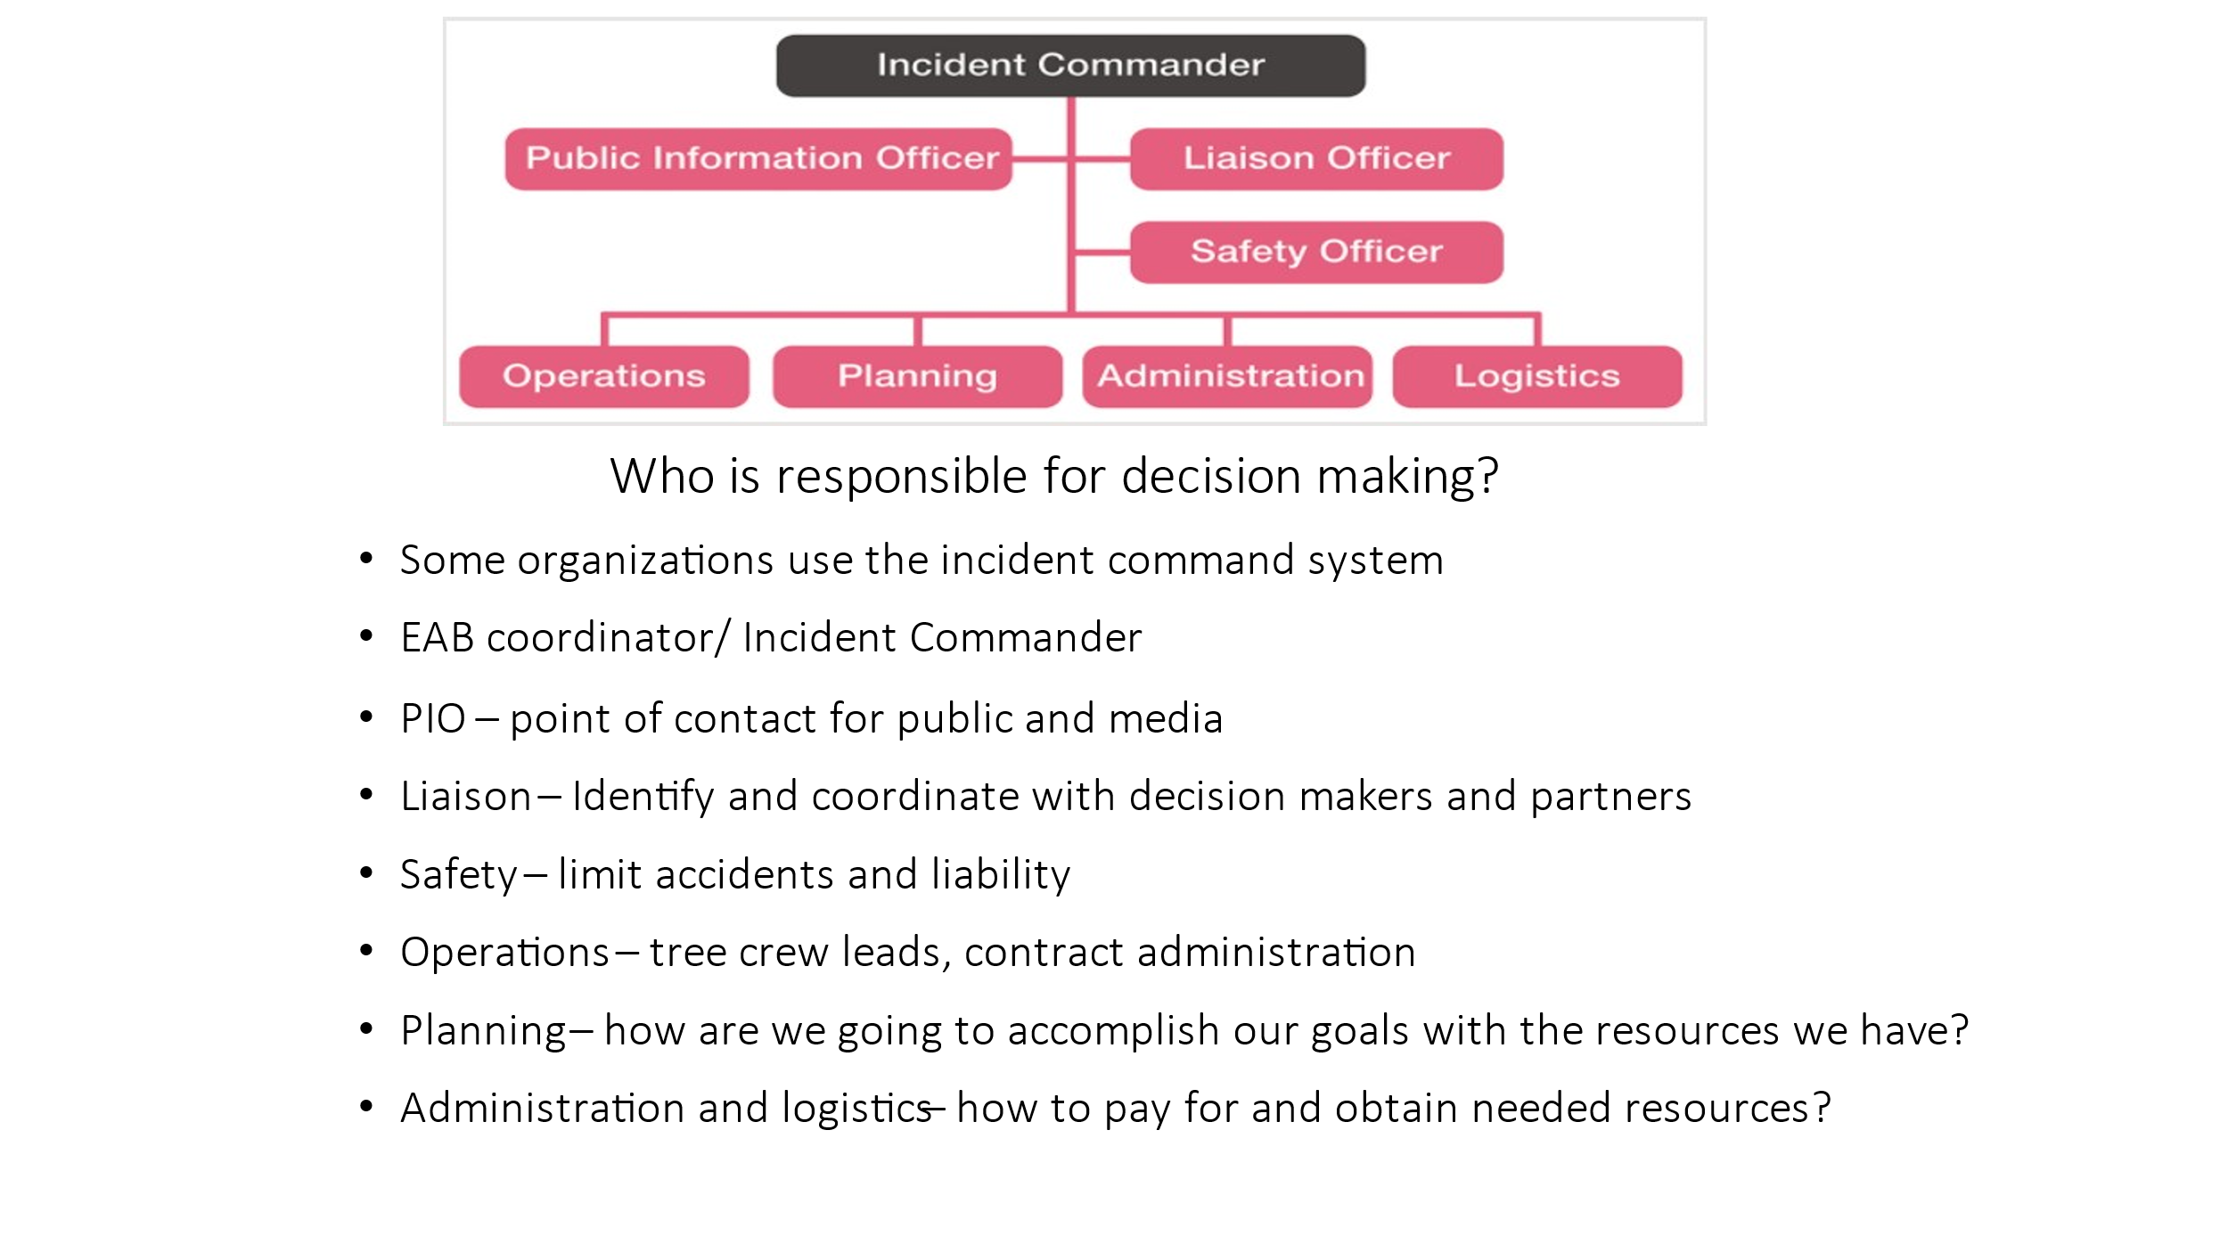
For more information about setting up an Incident Command System the FEMA site for NIMS Implementation and Training is a good resource.
https://www.fema.gov/emergency-managers/nims/implementation-training
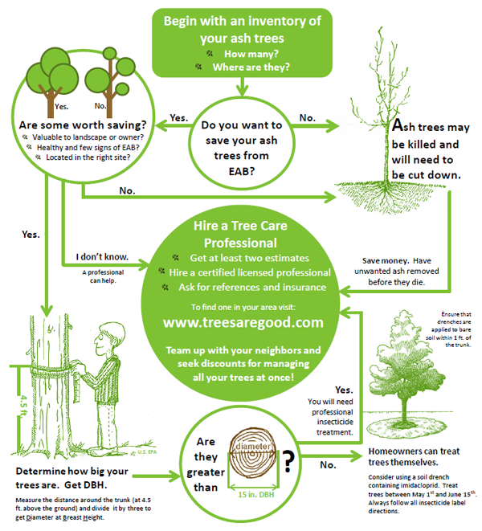
This infographic is an excellent example of what a decision-making matrix could look like as a source for public information.

Investigation
With the potential for a large volume of calls reporting possible incidents, it would be wise to develop a standard form that can be used for collecting data in a systematic format. When inspectors are sent out to examine potential infestations, such a form would prove useful by keeping everything documented in a consistent, systematic manner. The form should include the address and specific description of the location of infested tree(s) on the property.
See Appendix G: for a sample of a simple design for an inspection form.
Understanding what to look for during an investigation will be crucial in identifying trees that may be infested. The chart below shows what symptoms may be present and what stages of the insect can be expected to be found in a tree depending on how many years it has been infested. This information could be included on the inspection form.
Progression of Symptoms
Years Infested | Symptoms Present | EAB Presence
1 | None | Small larvae present
2 | Woodpecker damage possible | Large larvae and emerging adults
3 | Woodpecker damage likely with bark splitting possible | Increasing numbers of larvae all phases and emerging adults
4 | Visible impact to canopy
5-6 | Dead trees

<Enter your plan for local reporting potential EAB infestations here>

Reporting
It will be critical to set up a good system for reporting. Once the word gets out to the public, there will certainly be many calls of concern and reporting of sightings, etc. A great system may include a website where reports can be made and details about them can be accurately collected and documented for inspectors.

Report Findings from Branch Sampling Efforts
IDL's Forest Health Program created a StoryMap and a site for reporting possible detections of EAB. This survey documents ash trees in Idaho that have been tested for emerald ash borer infestation using the branch sampling method. All peeled branches should be recorded (branches that were not infested as well as branches that were infested).
Find a link to the survey reporting form at: https://linktr.ee/eabinfo.idl
This site can be accessed easily using a smartphone by scanning the QR code.
Scan the code and bookmark the site in the browser on your device for quick and easy reference.

See also Appendix D: Branch Sampling and Reporting, and Appendix H for Reporting Contacts

List of Contacts for Reporting
Idaho Department of Lands
Forest Health Program Manager – 208-666-8668
Urban & Community Forestry Program Manager – 208-626-1779

Idaho State Department of Agriculture
Pest Survey and Detection Manager – 208-332-8620

USDA Forest Service Intermountain/Northern Regions State and Private Forestry
Forest Health Protection
Boise Office 208-373-4225
Coeur d’Alene Office 208-765-7342

USDA-APHIS
State Plant Health Director – 208-373-1600

<List other important local/regional contacts here or use Appendix H>

Origin & Dissemination
It will be crucial to maintain a map that shows the original/first location of where the first report of EAB comes from in Idaho. The map should be continuously updated with each new discovery. This will help to establish response zones, and track where efforts need to be focused.
In studies that were performed to establish the distance that adult EAB can travel, it was found that results varied depending on several different factors, but the consensus was that fully mated females could travel up to 20 kms (or 12.5 miles). Therefore, it has been recommended that proximity boundaries for dissemination be established at 15 miles.

Delimitation
Quarantine/Regulation- Enforcement & Compliance
Because ISDA is not planning to implement any regulation or statewide quarantines, it may be necessary to set up a local system for quarantine in areas where EAB is discovered. Once that system is outlined, it will be crucial to work with stakeholders and law enforcement officials to establish protocol for enforcement and compliance. This will also be a good time to create a mapping system to track infestations and pest movement. (Use Appendix I for this)
Slide from Minnesota Dept. Ag (an example of statewide quarantine in Minnesota, that will not be implemented by ISDA)
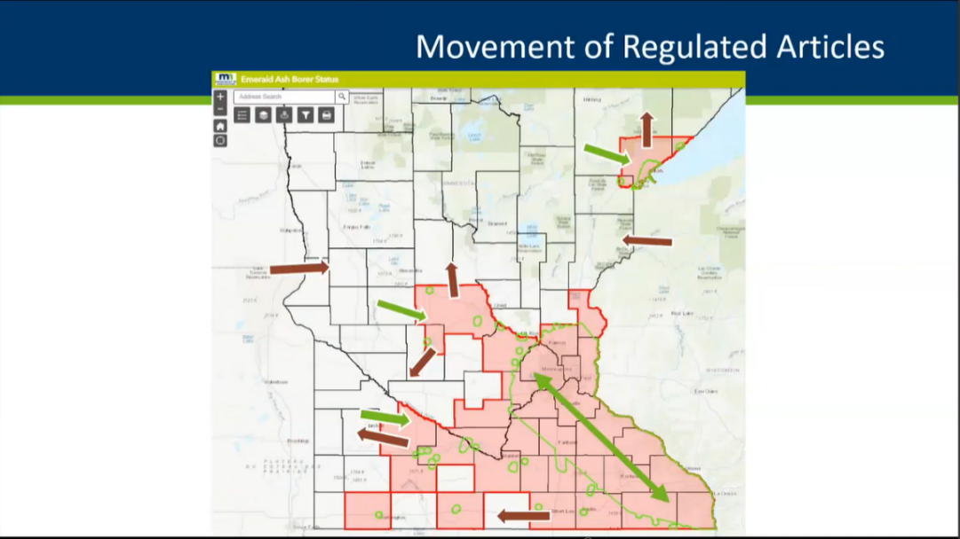
Above is an example of the quarantine system that is being used in Minnesota.
- The green areas are where EAB has been confirmed.
- Red areas are where the quarantine restricted boundaries have been set.
- Ash wood can be moved INTO an area that is restricted but cannot be moved OUT of a restricted zone.
- Restricted articles include any ash trees, any wood containing EAB, and any ash wood.

Management & Treatment

Tree Removal
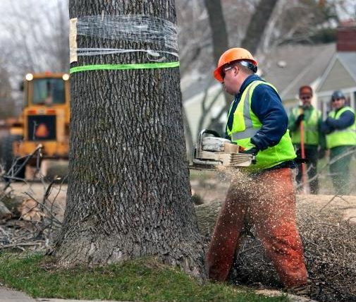
Photo Credit: Jeffrey Thompson
Will a system for proactively removing trees be used? Who will be responsible for the removal of right-of-way (ROW) trees? Which contractors will be doing the work, and will there need to be a permit process in place? The answers to these questions may need to be decided on a case-by-case basis. Proactively removing at-risk trees before EAB can infest them may be an option and can allow for costs to be spread over a period of time helping to manage budgets. Tree removal can be very expensive and can eat up budgets fast.
Dead ash trees left standing in the wake of EAB are a major concern for public safety. Trees killed by EAB become highly susceptible to fungi that act quickly on the dead trees accelerating decomposition and quickly drying out and weakening wood fibers. This severely compromises the structural integrity of the wood in branches and stems making them brittle, and more subject to failure. When trees are compromised in this way, they become more expensive to remove, because Arborists are no longer able to climb them safely, making the need for additional equipment necessary, increasing the cost of removal operations. Because of these reasons it becomes more important for a community to have a plan in place to remove trees killed by EAB quickly.
Lessons learned from the Slow Ash Mortality (SLAM) project have shown that proactively removing Ash trees does not have a significant impact on EAB populations and can increase the rate of spread. In these studies, it was found that treating trees helped to reduce EAB populations more than tree removal did.

If proactively removing trees is embraced, it becomes even more necessary to have an accurate inventory of your trees. GIS features in TreePlotter™ allows knowing where the ash trees are in your urban forest, they can then be prioritized according to their size and condition. Effort should be made to focus on trees that are in the worst condition and trees 10” or larger, as large trees have the greatest potential of harboring high quantities of EAB brood. The wood from these removals will need to be properly treated according to the disposal standards discussed earlier “Wood Waste Disposal and Treatment” section and in Appendix B.

Tree Preservation Efforts
Selecting ash trees for preservation due to historic significance or simply because of the contribution they make to the urban canopy presents a need for preventative treatments to keep them from becoming infested by EAB. The costs associated with treating trees proactively for preservation has proven to be more cost effective, taking up to twenty (20) years before matching the costs associated with removals.
Removing large numbers of trees from an urban canopy can mean that it will take 40 -50 years to replace those trees and the benefits they provide. Getting rid of all Ash trees will be a social decision, managing the urban forest in a community for the highest benefit and lowest cost is the responsible thing to do, and each community will have to make these decisions together on their own. The information in this guide is designed to help make those determinations.
When deciding whether to attempt to save or preserve a tree that has been affected by EAB it helps to understand that there are thresholds in all plant health care treatment protocols. Once a tree is exhibiting 50% or more dieback in the canopy therapeutic treatments are usually no longer effective, whereas trees exhibiting 30% or less are thought to be savable. Many different factors will need to be considered before administering treatment, including the general vigor of the tree and growing conditions present in the landscape. Are soil conditions and water content favorable to sustain continued and/or new growth? A site evaluation made by a qualified plant health care professional and/or certified arborist can help in make a decision.

Pesticide use in managing EAB
In studies that were performed during the development of the SLAM program, it was found that treating trees helped to reduce EAB population growth more than tree removal alone did.
Sound Integrated Pest Management Strategies (IPM) and Best Management Practices (BMP’s) are always highly recommended. As with any good IPM Plan, it is wise not to rely solely on pesticides or to go straight to the chemical shed as the first step to a solution. However, pesticides are a tool in the toolbox, and they can be a powerful, effective tool if used properly, and safety guidelines are followed.
Remember, when using pesticides; “The Label is The Law”.
Always refer to pesticide labels to make sure that the product you are planning to use is labelled for the application you intend to make. Be sure to talk to a Licensed Pesticide Consultant or Professional Pesticide Applicator in your area to help make the decision about which pesticide to use for your program. There are several application methods that have been proven to be effective in helping to manage EAB infestations.
- Contact/Foliar Application – This type of application is typically made with hydraulic spray equipment, and applications are made to the entire exterior surface of the trees. As you can imagine, this may not be the most favorably viewed application method in the eyes of the public. Risk to the public and the applicator themselves is also higher with these types of spray applications.
There are several pyrethroid based insecticides that are labeled for control of adult EAB. Always consult the pesticide label before making an application. Foliar applied insecticides can be an effective tool in your toolbox for treating adult EAB, their eggs, and preventing newly hatched larvae from entering the vascular system of a tree. Timing is critical when using this tool.

- Systemic Application – Systemic insecticides are absorbed into plants and translocated throughout their vascular system, where they are ingested by pests as they are feeding. These types of applications are much more favorably viewed, and safer for the public as well as the applicators who apply them. They are also often far more effective and have a much longer residual effect.
When using systemic insecticides, it is best to be sure that the trees being treated are well watered and healthy, because dry conditions and stressed-out trees will be less likely to absorb and translocate materials.
The cost and rate of application can vary depending on the product and the mode of delivery. There are three main methods of applying systemic insecticides that follow on the next page.
Methods of applying Systemic Insecticides

Soil/ Basal Drench
Product is mixed with water and the solution is applied to the soil, most commonly around the base of the tree. Be sure to pull back any foreign materials such as weed fabrics, and/or organic mulches and grass away from the targeted area of application, as these will often inhibit the uptake of the product.
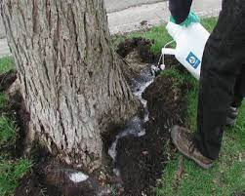
Photo Credit Purdue University

Trunk Spray
Trunk spray applications are usually made to and around the base of trees only, up to a specified height. These highly concentrated formulations are applied in small amounts of material that are then absorbed into the tree vascular system through lenticels in the bark. They typically require the addition of a surfactant to help move the solution into the tree. Some products may already have these surfactants built into the formulation.

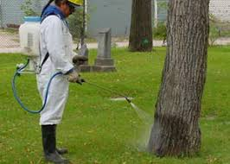
Photo source Utah State University

Direct Injections
This method of application uses specialized systems that deliver small amounts of highly concentrated solutions directly into the tree vascular system. Some systems will require pre-drilling holes into the trees and setting plugs that have one-way diaphragms built into them to keep solutions from leaking out after administration. It is highly recommended that only qualified persons trained in the correct use of this type of equipment are permitted to make this type of application, because if administered improperly, long lasting damage can occur to the trees and applications may not be effective.
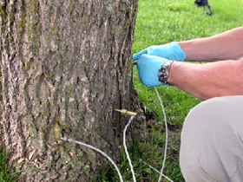

Trap Trees to Kill (bait & kill)
In the Trap to Kill method, trees are treated in the spring, and there is a waiting period to allow translocation of insecticide, then trees are girdled and turned into Trap Trees. EAB is then attracted to these trees and will lay eggs on them. As larvae develop, they are killed by the pesticides. If using Trap Trees this method is recommended.
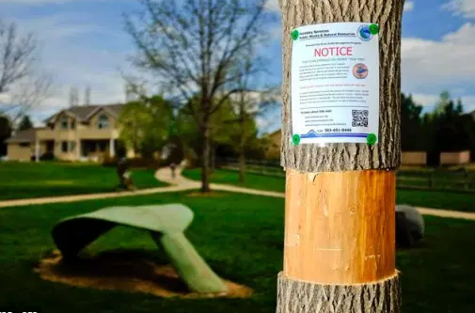
Pesticides and their efficacy in EAB management
Effectiveness of Systemic Insecticides on EAB Life Stages
Insecticide | Stage of Development
 | Egg | Larvae Instar |  |  |  | Toxicity of Poisoned Leaves to Adults
 |  | L1 | L2 | L3 | L4
Imidacloprid | No | Yes | Yes | No | No | with sustained feeding
Dinotefuran | No | Yes | Yes | No | No | a few bites
Emamectin Benzoate | No | Yes | Yes | Yes | Yes | one or two bites
Azadirachtin | No | Yes | Yes | Yes | Yes | non-toxic but reduces fecundity of adults

Long Term Management: Biocontrol
USDA APHIS has been researching natural enemies of EAB that occur in the insects’ native range (China, Russia, Japan, and Korea). Four insects have been identified as showing promise at controlling EAB populations. These parasitic wasps give some hope that one day the EAB may not be such a devastating pest.
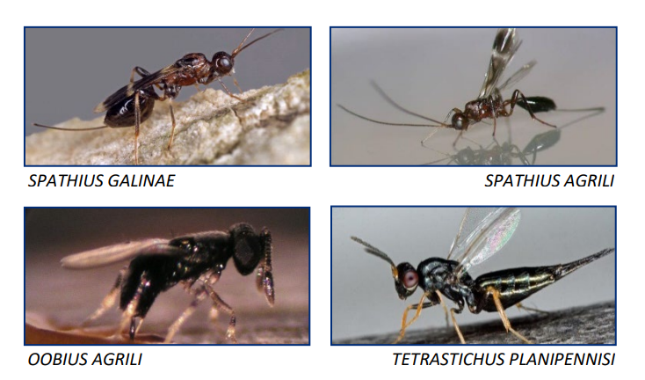
These bio-control agents have been most effective in densely forested areas in the East and Midwest at least 40 acres in size where tree stands are 25% ash or higher. In addition, parasitoid release sites should ideally contain a variety of ash size classes ranging from seedlings to mature trees. Because Idaho has no natural stands of ash trees, and all our ash trees are confined to urban areas, where densities are typically lower than 25%, Idaho cities may not be a good place to use these bio-controls, as there would not be enough resources to support the natural regeneration of the parasitoids. Learn more about biological control of EAB here: https://www.aphis.usda.gov/plant_health/plant_pest_info/emerald_ash_b/downloads/eab-field-release-guidelines.pdf

Funding
The Idaho Department of Lands Urban and Community Forestry program is receiving funding from the USFS through the Inflation Reduction Act (IRA) which has invested $1.5 billion in Urban and Community Forestry nationwide. With this funding, IDL plans to make additional programs available to help communities offset the costs associated with planning and responding to invasive pests across Idaho. These funds will be awarded on a competitive basis to Idaho communities that have been determined to be “disadvantaged” using the Climate and Economic Justice Screening Tool (CEJST). Plans to roll out these funding programs are currently underway and expected to be announced as soon as the funds are secured. Projects that qualify will include Urban Forest Inventory, Tree Risk Mitigation, and Tree Planting. If you have questions and would like to learn more about the Idaho IRA program, please reach out to the IDL UCF program manager.

Appendices
- Additional Resources
- List of Approved Local Professional Tree Services/ Contractors
- Sample Specifications
- Branch Sampling and Reporting
- Sample Press Release
- Sample Organizational Flow Chart
- Form/ Template for Inspections
- List of Contacts for Reporting
- Map of Areas of Infestation for Tracking Pest Movement

Appendix A: Additional Resources
USDA
https://www.aphis.usda.gov/aphis/ourfocus/planthealth/plant-pest-and-disease-programs/pests-and-diseases/emerald-ash-borer
Emerald Ash Borer University
http://www.emeraldashborer.info/EABU
State of Colorado EAB Info
http://www.emeraldashborer.info/state/colorado.php
https://beasmartash.org/
State of Oregon EAB Response
https://www.oregoninvasivespeciescouncil.org/eab
https://static1.squarespace.com/static/58740d57579fb3b4fa5ce66f/t/60772a17647ad466155f74a7/1618422303582/March+2021_EAB.pdf
State of Washington Urban Forest Pest Readiness Plan
https://invasivespecies.wa.gov/projects/pest-ready/
State of Michigan EAB Info
https://www.michigan.gov/invasives/id-report/prohibitedrestricted/emerald-ash-borer
North Dakota State University ash tree identification
https://www.ag.ndsu.edu/publications/lawns-gardens-trees/ash-tree-identification

Appendix B: List of Approved Local Tree Services
Many city ordinances call for tree services that perform work on public right-of-way trees to be on an approved list of vendors who have been vetted through a program to ensure that they meet certain requirements such as the ANSI A300 Tree Care Operations Standards.
<List Tree Service Professionals who have met these criteria here>

Appendix C: Sample Specifications

Wood waste generated during the removal of EAB infested trees shall be disposed of according to the following specifications.
- Chipping:
All wood, brush, and stump grindings must be chipped to the minimum size of no more than 1” X 1” (one square inch). Since typical tree care operation equipment does not reliably meet these specifications, it may be necessary to pass materials again through a chipper or tub grinder equipped with a 1” screen to assure compliance.
- Debarking:

All wood (trunk and stem pieces, including that which is to be used as firewood) that is retained from removed ash trees (infested with EAB or not) shall at minimum have the bark completely removed. Preferred best practice is to remove bark and up to 1/2” of sapwood beneath the surface of the bark. Additionally, all debris created from this process shall be processed to the “chipping” specifications above.

- Heat:
Green lumber, logs, and firewood require kiln sterilization or heat treatment in an APHIS approved facility. To treat for regulated pests and diseases, internal core wood temperatures must reach 160 degrees F for 75 minutes to meet established BMPS.
USDA Kiln Certifications, treatments and labeling guidelines can be viewed here:
https://www.aphis.usda.gov/publications/plant_health/fs-eab-transition.pdf

Additional resources for planning an Urban Wood Disposal and utilization Program Here: https://urbanforestrysouth.org/resources/library/ttresources/community-urban-wood-utilization-planning-worksheet

*Note - It is worth mentioning that the specifications above for Debarking and Heat Treatment may be very difficult for many communities to meet, as there are no known APHIS certified heat treatment or debarking facilities in or near the state of Idaho. It should therefore be left up to each community to build their own specifications and wood waste treatment programs.

Appendix D: Branch Sampling and Reporting
How to use these tags to monitor for the emerald ash borer

Branch sampling is a highly effective monitoring tool to detect emerald ash borer, even before an infested tree becomes symptomatic. The purpose of branch sampling is to look for emerald ash borer galleries and larvae in the sapwood of ash tree branches. These methods have been adapted from a Canadian research study (Ryall, Fidgen & Turgeon, 2011) where branch sampling successfully detected 74% of asymptomatic trees that were infested by emerald ash borer.

To conduct branch sampling, 2 branches are collected from each sampled ash tree. The branches are then brought back to the shop, where they are peeled with a draw knife. The sapwood is examined for signs of emerald ash borer, such as S-shaped galleries, larvae, or pupae. Typically, many branch samples are stored up in the shop and then peeled as time allows in order to be efficient.

Since branch samples are usually peeled in bulk at the shop, it is critically important to know the location of the ash tree from which they were cut.

These tags are for labeling cut branch samples with the location of the sampled tree, and then reporting the results.

Side 1: When the branch sample is cut, the arborist writes down the location of the
sample tree on the blank side of the tag. The tag is then securely zip-tied around the branch sample, and the branch sample is transported back to the shop. If the branch samples are small enough, the tag can be used to zip tie both branch samples together (from the same tree).

Side 2: The other side of the tag shows very basic instructions for branch sampling and has a very important QR code that must be scanned.
The QR code, also accessed via this link: linktr.ee/branchpeeling, will take you to a Branch Sampling page with 2 options:

1) Full Instructions, Photos & Videos
2) Report Results for each sample
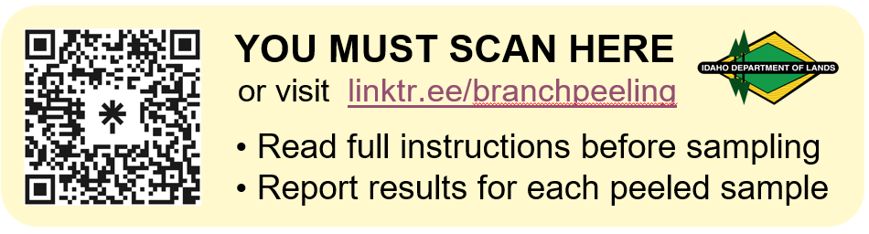

The Full Instructions option directs you to the full, detailed instructions for conducting emerald ash borer branch sampling. This page contains very important information that is not included on the tag alone. There are many photos & videos of branch sampling techniques and signs of EAB. It is essential to review this page in addition to the information on the tag before conducting branch sampling. Direct link: https://arcg.is/0Hjb0y

The Report Results option directs you to the Idaho statewide EAB branch sampling reporting portal. Report the results of all branch sampling, including trees that were not infested. Entries should be made when the branch sample(s) is(are) peeled. Make one entry for each sampled tree, not each branch. Link: https://arcg.is/1mWCei YOU MUST REPORT ALL RESULTS.

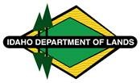
Please email ForestHealth@IDL.idaho.gov
with any questions or feedback.

EAB Branch Sampling FAQs

Who should conduct branch sampling to monitor for EAB?
Anyone can participate in branch sampling for emerald ash borer at whatever capacity they can manage. Ideally, we would like to see city forestry departments and professional tree care companies implement branch sampling, either in conjunction with their normal pruning activities, or in their own systematic survey. However, citizen scientists and other groups can also conduct and report branch sampling.

How do I know which trees to sample?
Any ash (Fraxinus) tree is suitable for branch sampling if it has at least two prune-able branches that are at least 2”-3” in diameter. You will choose which suitable ash trees to sample based on your organization’s capacity. Keep in mind that sampling 50 trees will generate about 50 hours of labor. The Idaho Department of Lands (IDL) will not be directing on which trees to sample, how many trees to sample, or what years to sample. IDL is available for answering questions, providing guidance, and maintaining the branch sampling reporting portal.

When should I conduct branch sampling?
Branch sampling (both the collecting and the peeling of the branches) should be completed between October and April when the larvae/pupae are overwintering in their host trees. You can start branch sampling during the winter/spring of 2023 and continue every year if you have the capacity.

Who peels the branches?
You will peel your own branch samples and report your results in the reporting portal, do not send them to the Idaho Department of Lands for peeling.

Can branch samples from other states be entered in the reporting portal?
The reporting portal is intended for the state of Idaho, but results from other states will be accepted.

Appendix E: Sample Press Release
Contact: (Name), <title>, xx
Emerald Ash Borer Found in <Location>, Meeting Planned
<City/Location>, ID
Emerald Ash Borer (EAB) an exotic beetle that infests ash trees, has been discovered in the <City/Location> area. EAB is now considered to be the most destructive forest pest in North America and has the potential to cause billions of dollars in damage nationwide if not dealt with.
The <city here> is sponsoring an Informational meeting on this destructive pest on <date, time> at <meeting location> and the public is invited.
EAB specialists from <resource here> and regulatory specialists from <agency here> will be present to explain what EAB is and how it will be handled.
“This is a very destructive pest, and people need to know what to look for, and what to do if they find it”, says <name, title>. “Information will be provided about how to identify the Emerald Ash Borer, the signs and symptoms of an infestation, the treatment options that are available, and good options for replacing ash trees with alternative species. There will also be information from an Idaho State Department of Agriculture representative on invasive pest regulations and quarantine measures.”
For more information, call <name> at XXX-XXX-XXXX. Additional information about EAB can be found at WWW.xxxxxxxxxx

Appendix F: Organizational Flow Chart for Reporting (Example)

Appendix G: Sample EAB Inspection Form
This form is designed with the intent to provide guidance for performing a systematic evaluation of ash trees to determine the presence of Emerald Ash Borer.
EAB ONLY attacks Ash trees*
(* in some instances, EAB will also attack Chionanthus spp. or other Oleaceae family (Olive) trees, but this is irrelevant because these are not a common species in Idaho)
☐ Tree has opposite branching habit.
☐ Tree has odd pinnately compound leaves with 5–9 leaflets with a smooth or finely toothed margin.
Checklist for signs/ symptoms of EAB
☐ Canopy shows signs of thinning and/or dieback.
☐ Epicormic growth in scaffold branches, not associated with over pruning.
☐ Epicormic growth at base of tree and/or suckers.
☐ Signs of woodpecker activity, bark flecking or “blonding”.
☐ Vertical lesions along scaffold branches and/or trunk with missing or loose bark and signs of borer activity (frass & galleries).
☐ “S” shaped galleries caused by borer larvae feeding under bark in cambium region.
☐ “D” shaped exit holes (approx. 1/8” in diameter).

Tree Location
Address _____________________________________________________

Appendix H: List of Contacts for Reporting
Idaho Department of Lands
Forest Health Program Manager – 208-666-8668
Urban & Community Forestry Program Manager – 208-626-1779

Idaho State Department of Agriculture
Pest Survey and Detection Manager – 208-332-8620

USDA Forest Service Intermountain/Northern Regions State and Private Forestry
Forest Health Protection
Boise Office 208-373-4225
Coeur d’Alene Office 208-765-7342

USDA-APHIS
State Plant Health Director – 208-373-1600

<List other important local/regional contacts here>

Appendix I: Map of Idaho Communities where pest has been detected.
<Insert a map when one becomes available>.

Endnotes/References

Ecological Economics “Cost of potential emerald ash borer damage in U.S. communities, 2009-2019” Kent F. Kovacs et.al. https://www.nrs.fs.usda.gov/pubs/jrnl/2010/nrs_2010_kovacs_001.pdf
“Science Findings January/February 2014 Exploring Connections Between Trees and Human Health” Marie Oliver https://www.fs.usda.gov/pnw/sciencef/scifi158.pdf
From page 31 EAB Travel Distance Taylor, R.A.J., et al. 2006. Emerald ash borer flight estimates revised. In: Emerald ash borer and Asian longhorned beetle research and technology development meeting. Cincinnati, Ohio: Forest Health Technology Enterprise Team, USDA. Taylor, R.A.J., et al. 2005. Is emerald ash borer an obligate migrant? In: Emerald ash borer research and technology development meeting. Pittsburgh, Pennsylvannia: Forest Health Technology Enterprise Team, USDA.
SLAM – An Integrated Strategy to SL.ow A.sh M.ortality in Emerald Ash Borer Outlier Sites. Steven Katovich, USDA Forest Service, Forest Health Protection et.al.

