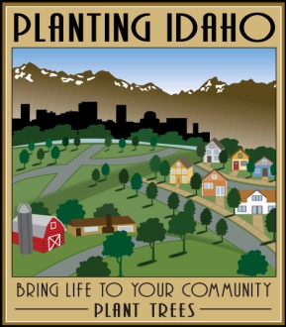
2024 Arbor Day Grant Program
“PLANTING IDAHO”

Application Form (return by March 22)
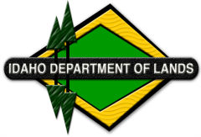
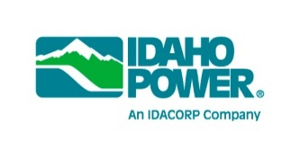
Community Applying
Contact Person
Position
Mailing Address
City |  | State |  | Zip
Email
Phone/Cell Phone
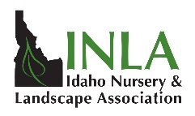
IMPORTANT
You MUST also submit a copy of your Arbor Day Proclamation signed by a community official with this application.
- When is your community planning to celebrate Arbor Day?

2. Arbor Day Event:
Describe the Arbor Day Celebration your community is planning and how this grant will help your community’s celebration.
3. Have you considered overhead utilities when selecting tree species for this site? |  | Yes No
There will be no reimbursements for purchase and/or planting of Fraxinus (ash)
Authorized Signature:
I certify the celebration described in this application is approved and supported by my community’s government.

__________ ____________________________________ ______________
Date Authorized Signature Title

Return to: Idaho Nursery and Landscape Association
2445 John Adams, Idaho Falls, Idaho 83401
OR email to: abates@plantingidaho.org
Questions? Ann Bates – (208) 419-8118
Website: inlagrow.org

Note: Applications may be returned by mail or email but must be received in the INLA office no later than March 22, 2024. All applicants will be notified the week of
March 25.

