2024 Arbor Day Grant Program
“PLANTING IDAHO”

Idaho Nursery & Landscape Assoc.
2445 John Adams
Idaho Falls, Idaho 83401
Arbor Day Grant Program
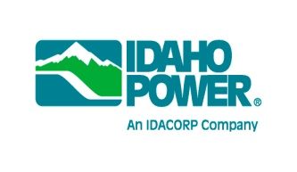
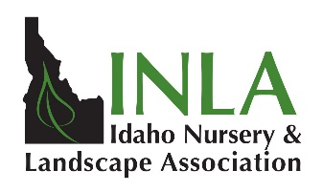
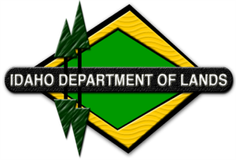
The Idaho Nursery and Landscape Association (INLA), in cooperation with the Idaho Department of Lands (IDL), Avista, Rocky Mountain Power, and Idaho Power, is pleased to announce a program intended to help communities celebrate Arbor Day, plant appropriate trees for energy conservation and foster a stronger relationship between Idaho communities and the Green and Utility Industries. NEW this year, 45 Arbor Day grants in the amount of $350 will be awarded for “Planting Idaho”. Funding for this program is provided by the generous contributions of these Idaho utilities that have a large interest in healthy urban forests and having the right tree planted in the right place.

All Idaho communities are eligible to participate in the “Planting Idaho” program (unless they have received the grant funds previously in both 2022 and 2023). Grant funds can only be used for purchasing trees (excluding Fraxinus varieties) and shrubs and/or related planting and care materials for your community’s Arbor Day celebration. A lottery style drawing will be used to determine who receives each of the 45 available grants. Applications, along with a signed Arbor Day proclamation, must be received by INLA no later than March 22, 2024 to be considered. Plant material must be purchased from an Idaho State Nursery & Floral license holder. A list of INLA members can be found at www.inlagrow.org so you can purchase quality plant material and receive reliable advice on selection, planting, and care; thus, ensuring a significant positive impact on Idaho’s environment.

This is a reimbursement grant. Therefore, after being chosen for this grant, an accomplishment report will be required and grantee communities must submit copies of paid invoices for plant materials, with check numbers to receive reimbursement. Additionally, a match of 25% ($88) in cash or in-kind donation is required by the grantee.

Idaho joins most other states in celebrating Arbor Day on Friday, April 26, 2024. However, trees and planting conditions don’t honor calendars – your community may choose to celebrate Arbor Day on a different date.

Questions? Ann Bates – 1-208-419-8118 – abates@plantingidaho.org

The application can be found online at: www.inlagrow.org

