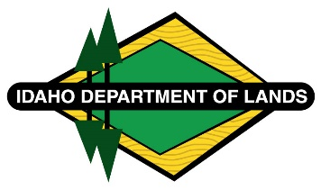
Negotiated Rulemaking Meeting for IDAPA 20.03.13
Administration of Cottage Site Leases on State Lands
Docket No. 20-0313-2401
March 27, 2024, 1:00 p.m.
Boise, Idaho and Zoom

Participant List – March 27, 2024
IDAPA 20.03.13

IDL Staff:
Tammy Armstrong – In Person
Jason Laney – In Person
Addie Faust– In Person
Kemp Smith – in Person
Anna Maria Mancini – Zoom
Roger Hall - Zoom

In Person Participants:
Bruce Smith

Zoom Participants:
Allison Olson – DAG (Deputy Attorney General)
Randy Fox – Idaho Conservation League

