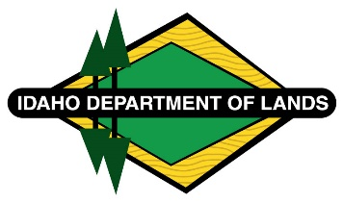
Negotiated Rulemaking Meeting for IDAPA 20.03.14
Rules Governing Grazing, Farming, Conservation, noncommercial Recreation, and communication Site Leases
Docket No. 20-0314-2401
March 27, 2024, 5:00 p.m.
Boise, Idaho and Zoom

Participant List – March 27, 2024
IDAPA 20.03.14

IDL Staff:
Jason Laney -In Person
Diana Barbour -In Person
Roger Hall -In Person

In Person Participants:
Dexton Lake – Idaho Farm Bureau
Russ Hendricks – Idaho Farm Bureau,
Allison Ginn -USFS
Cameron Mulrony – Idaho Cattle Association (ICA)

Zoom Participants:
Allison Olson – Office of Attorney General
Karen Williams – Idaho Cattle Association (ICA)

