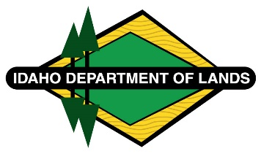
Negotiated Rulemaking Meeting for IDAPA 20.03.14
Rules Governing Grazing, Farming, Conservation, Noncommercial Recreation, and Communication Site Leases
Docket No. 20-0314-2401
April 4, 2024, 1:00 p.m. (MT)
Idaho Falls, Idaho and Zoom

Participant List – April 4, 2024
IDAPA 20.03.14

IDL Staff:

Jason Laney -In Person
Heath Hancock -In Person
Roger Hall – Zoom

In Person Participants:

Cameron and Janel Williams- Idaho Citizen Grazing Association/ Chesterfield L&L Russ Hendricks – Idaho Farm Bureau,

Zoom Participants:

Allison Olson – Office of Attorney General
Randy Fox-Idaho Conservation League (ICL)
Patxi Larrocea-Phillips- Idaho Cattle Association (ICA)/ Idaho Wool Growers Association (IWGA)

