***COURTESY POSTING***

The State Idaho Department of Lands ("IDL") is requesting Bids from qualified Vendors for efficient completion of Mustang Fire Drone Stocking Survey work. All available solicitation documents are available on IPRO powered by Luma as detailed below.

To view and respond to this solicitation, please register in the State of Idaho eProcurement system here Luma IPRO Supplier Portal and search for the solicitation number.

The Invitation to Bid is ITB # 1200 Mustang Fire Drone Stocking Survey.

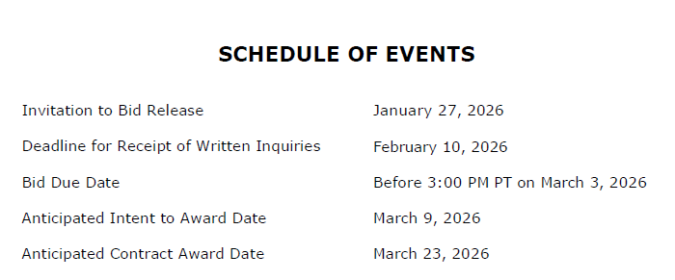

The main Contact for this event is:

Sherry Leason
Contract Officer
208-666-8659
Sleason@idl.idaho.gov

If you have any questions on registering or navigating IPRO powered by Luma, please reach out to supplierportal@sco.idaho.gov.

THIS IS ONLY A COURTESY POSTING. ALL RESPONSES MUST BE SUBMITTED IN IPRO POWERED BY LUMA.

